**Mock Data Generation using Mockaroo**

**‘’ RETAIL STORE MANAGEMENT SYSTEM “**

**D12B_01**

**GROUP NO. 01**

**USERNAME : D12B1**

**PASSWORD : D12B1**

**SVN : S**ANJANA **, V**IVEK **, N**ISHTHA

<https://www.mockaroo.com/8ab16af0> order 1000

<https://www.mockaroo.com/719bb9f0> cust 500.

<https://www.mockaroo.com/02cb7080> prod 105.

<https://www.mockaroo.com/2481e9d0> staff 210.

<https://www.mockaroo.com/3aac42a0> store 30.

<https://www.mockaroo.com/45da2f40> ft 1000

<https://www.mockaroo.com/12ee3270> time 50

Date format : mm-dd-yyyy

Staff_id removed from order and ft

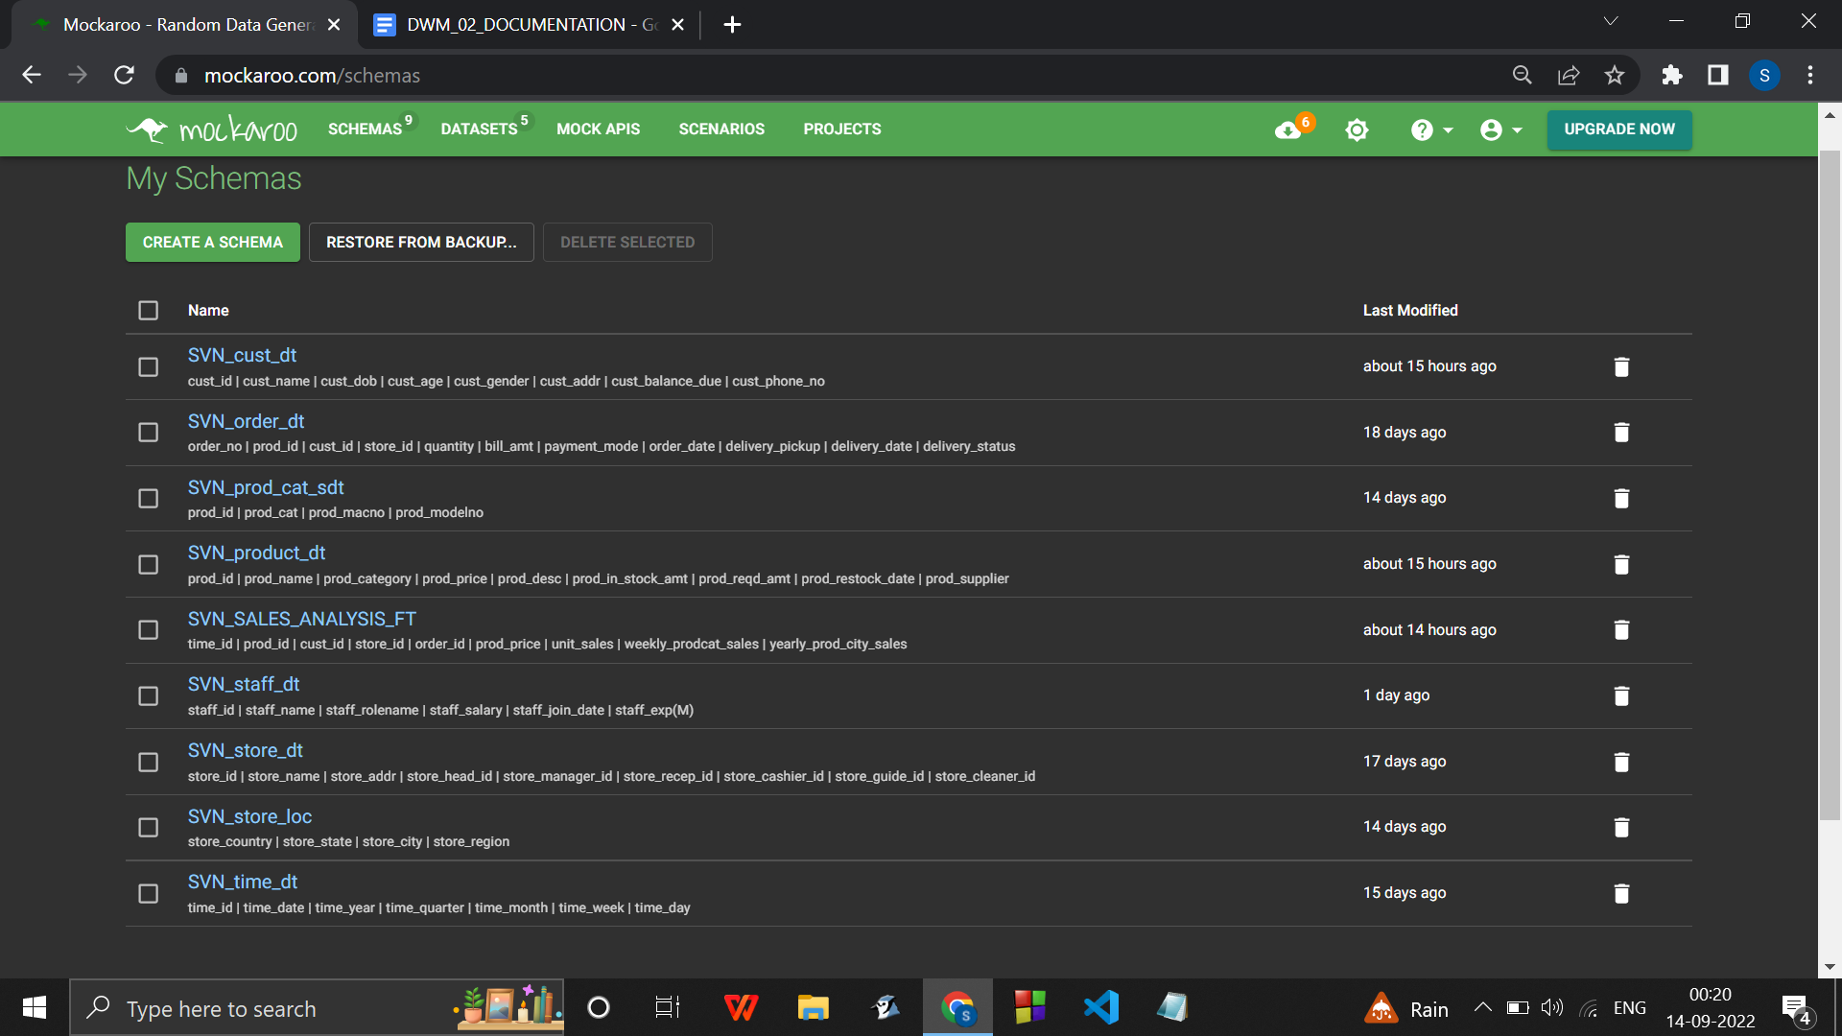

ASSUMPTIONS :

1. AN ORDER CAN HAVE ONLY 1 TYPE OF PRODUCT IN IT SINCE NORMALIZATION OF COMMA SEPARATED ENTRIES OF PRODUCTS ORDERED WILL HAVE TO BE PERFORMED.
2. A CUSTOMER CAN ONLY ORDER ONCE. I.E. NO CUSTOMER WOULD BE REPEATING IN THE ORDER TABLE.SIMILARLY , ONE STORE : 1 SALE .
3. A MANAGER OF 1 STORE CAN BE A CLEANER FOR OTHER STORE

Sign in to mockaroo to save all the schemas

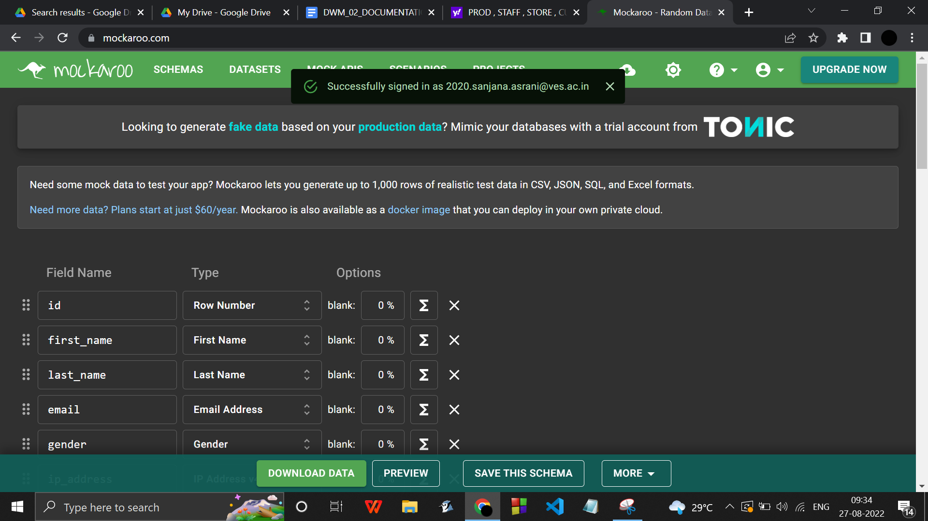

Click on save this schema after selecting appropriate datatypes for all attributes.

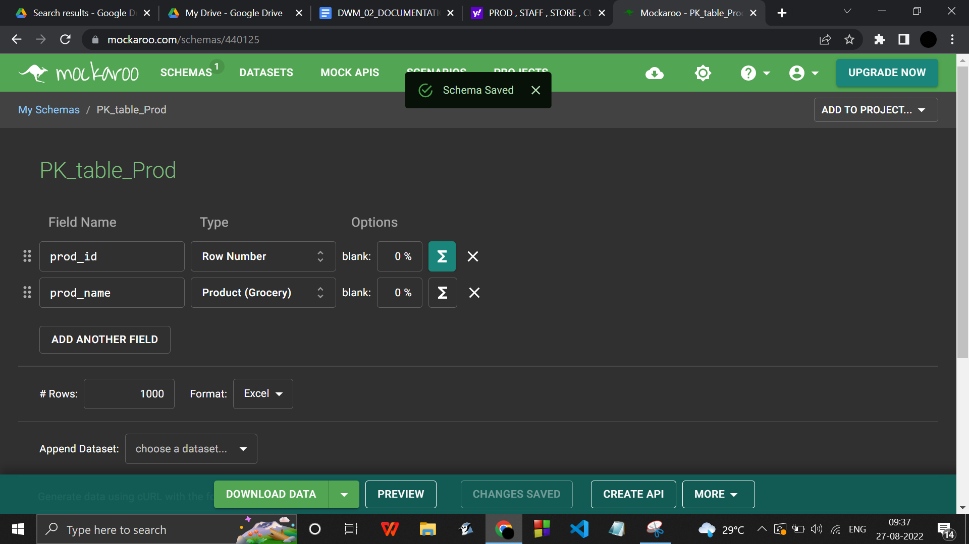

Save any changes that are made inside a schema.

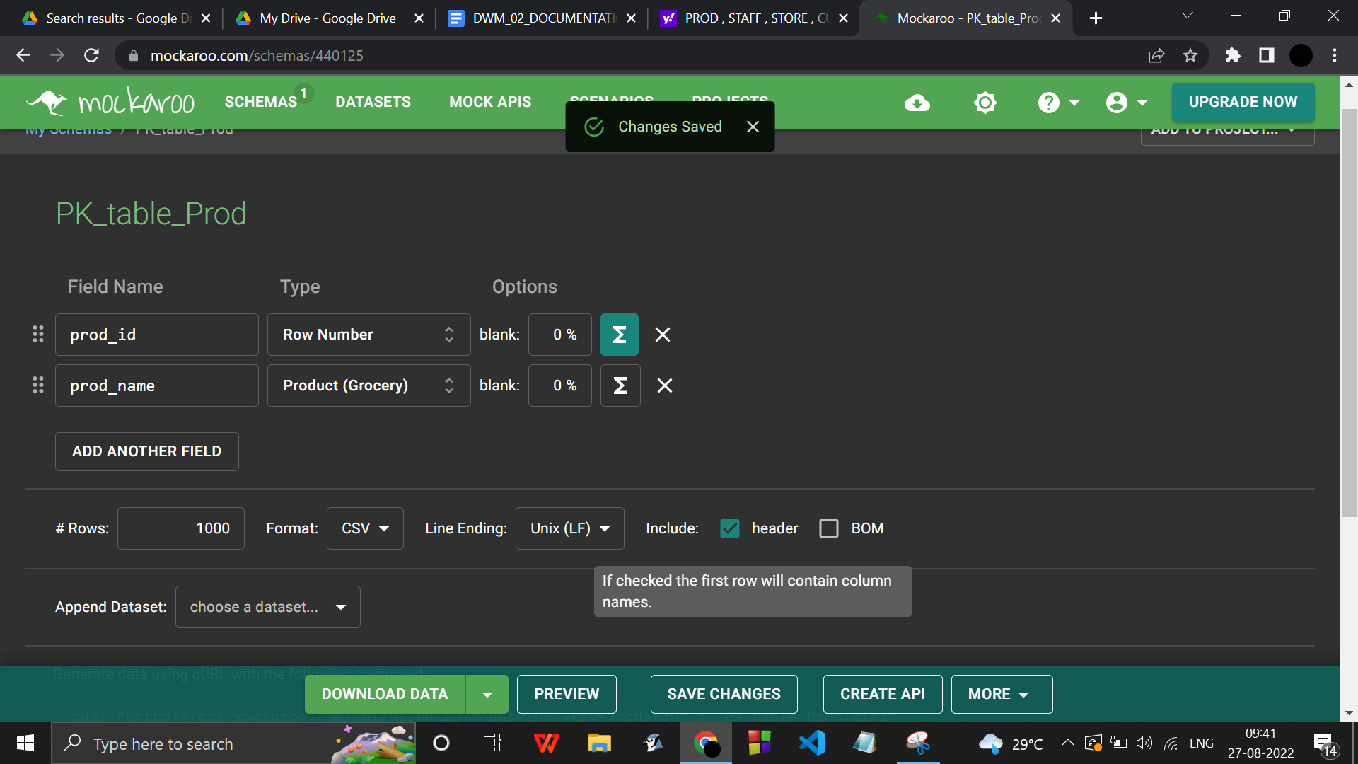



All dimension tables

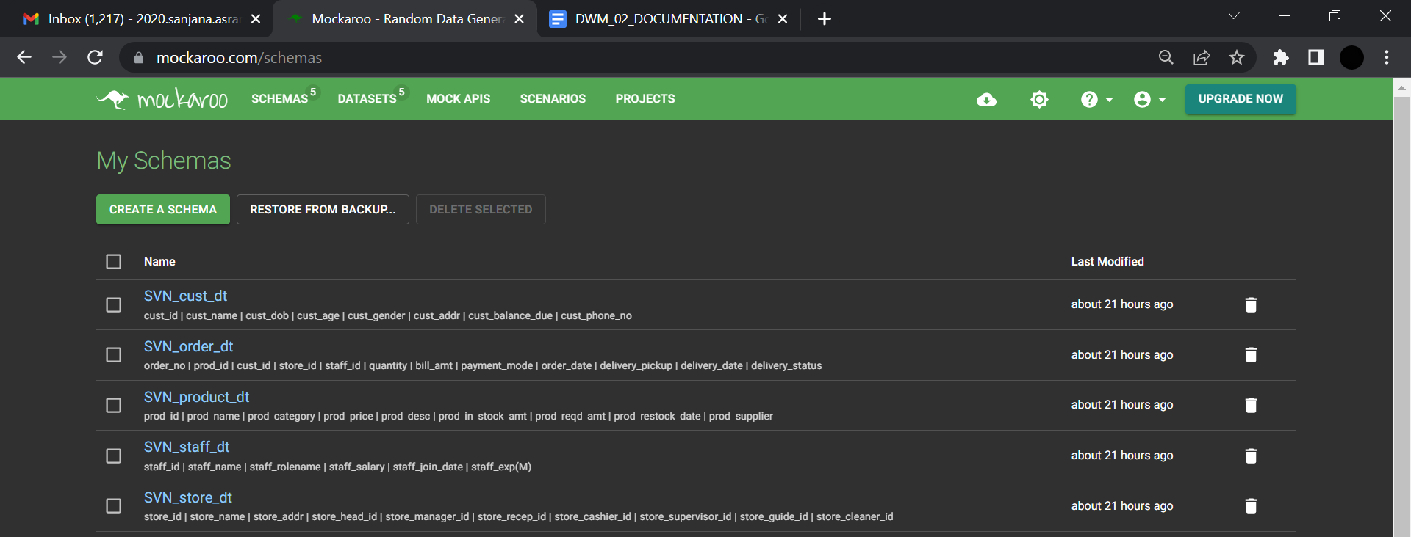

ALL DATASETS

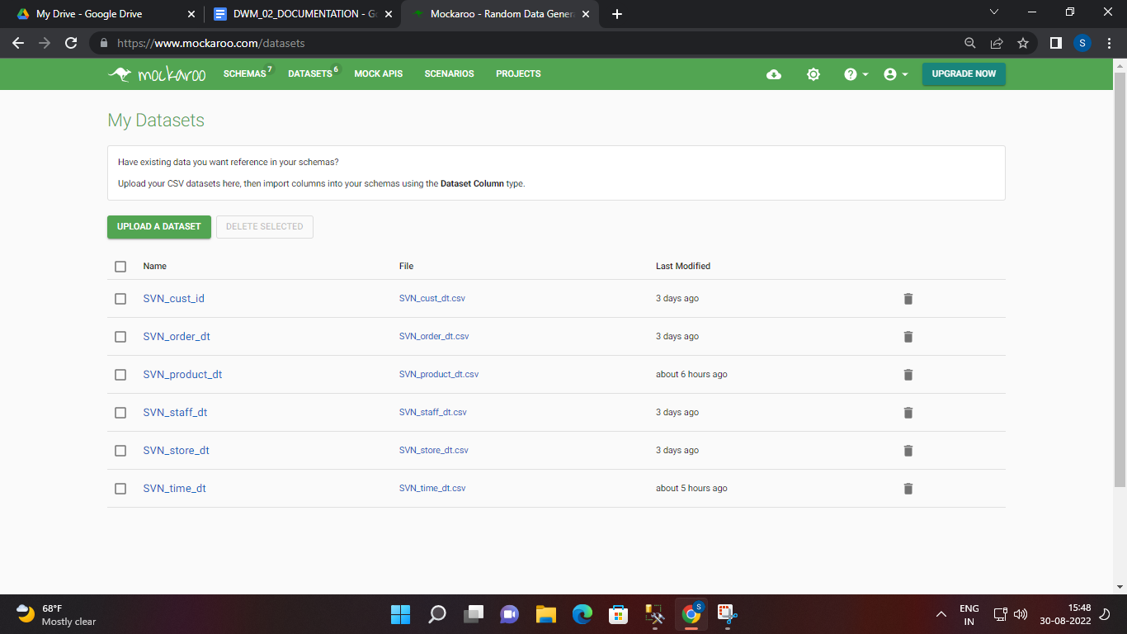

***SVN_cust_dt***

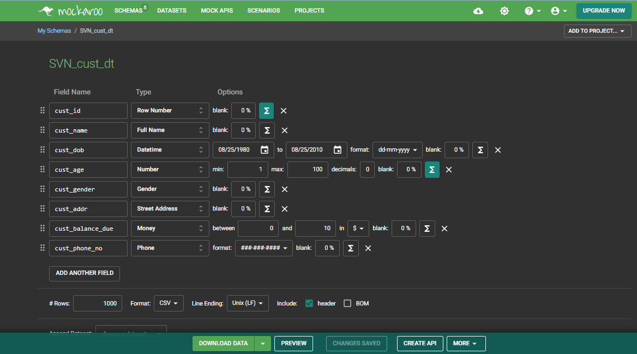

Click on the  symbol on the right of an attribute to add a formula to it.

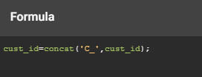

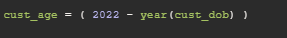

Inserting values into SVN_cust_dt ( Preview)

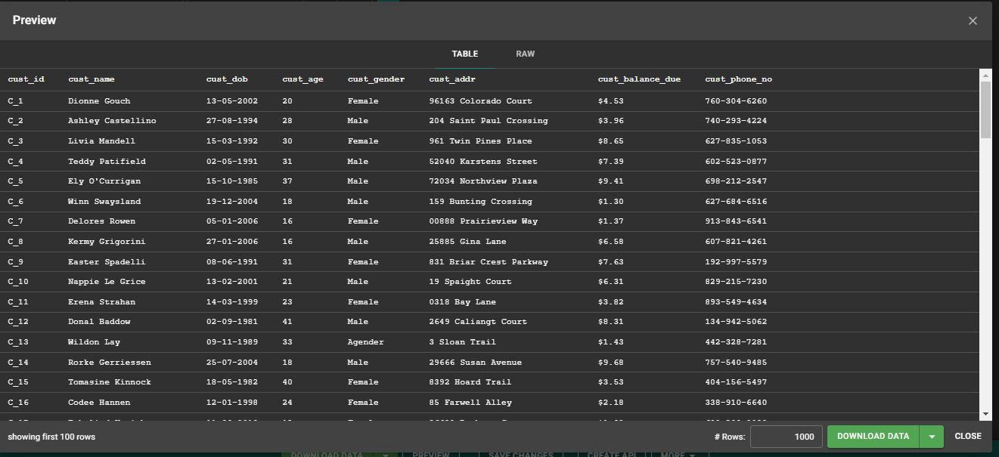

***SVN_prod_dt***

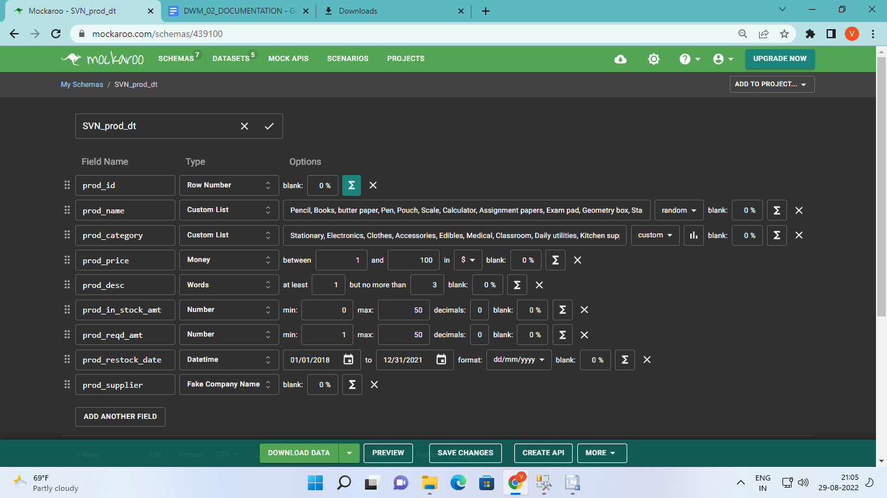

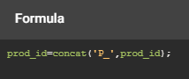

prod_category->type : Custom list ->from 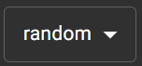dropdown select 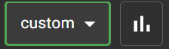

Click on the symbol to add a custom distribution

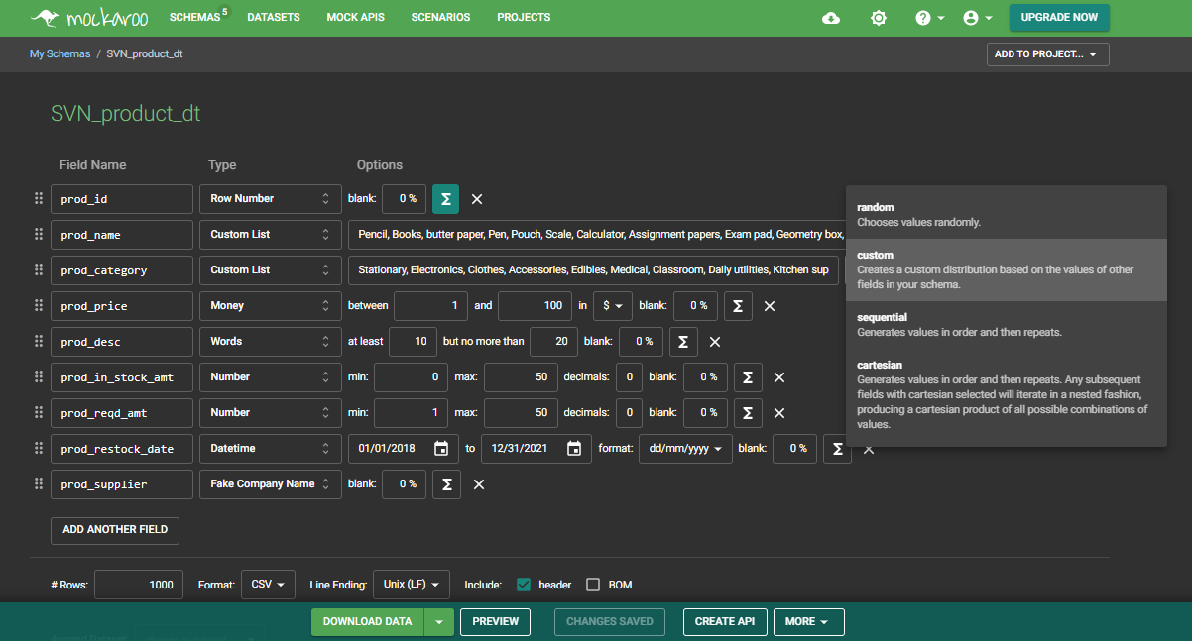

prod_name

**Stationary**

Pencil, Books, butter paper, Pen, Pouch, Scale, Calculator, Assignment papers, Exam pad, Geometry box, Stapler, Punch machine, drawing kits,

**Electronics**

TV, Desktop, Laptop, Mobiles, Printer, AC, Heater, Induction, Fan, Projector, Mixer grinder, Deep fryer,

**Clothes**

Jeans, Tshirts, Shirt, Tops, Undergarments, Saree, Kurta, Napkins,

**Accessories**

Earrings, Necklace, Watch, Goggles, Rings, Shoes, Heels, Spectacles, Rubber bands, Nail paint,

**Edibles**

Chips, Icecreams, Frozen foods, Packed ice, Chocolates, Coffee, Tea, Rice, Oils, Sauces, Salad Dressings, Condiments, Cereals, Butter, Cheese, Eggs, Pet food,

**Medical**

Masks, Sanitizers, PPE kit, Gloves, Thermometer, Oximeter, Bandages, Dettol, Medicines,

**Classroom**

Chalks, Slates, Boards, Benches, Markers, Dusters,

**Daily utilities**

Razor, Shaving cream, Face creams, Makeup, Talcum powder, Soap, Tissue papers, Period supplies, Wall paint,

**Kitchen supplies**

Knife, Pan, Spoon, Plate, Bowl, Glass, Fork, Serving spoon, Cooker, Rolling pin, Strainer, Grater, Jar, Dishwasher, Cutting board, Egg beater

prod_category :

Stationary, Electronics, Clothes, Accessories, Edibles, Medical, Classroom, Daily utilities, Kitchen supplies

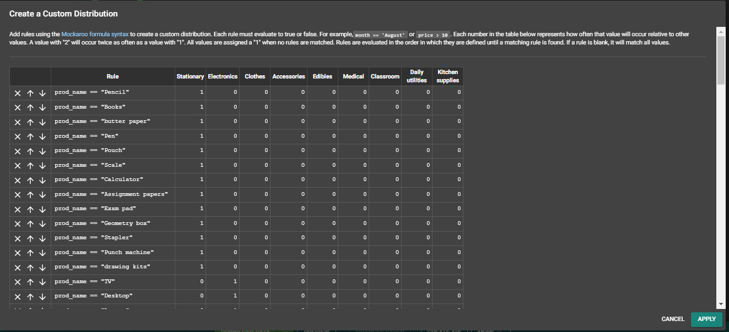

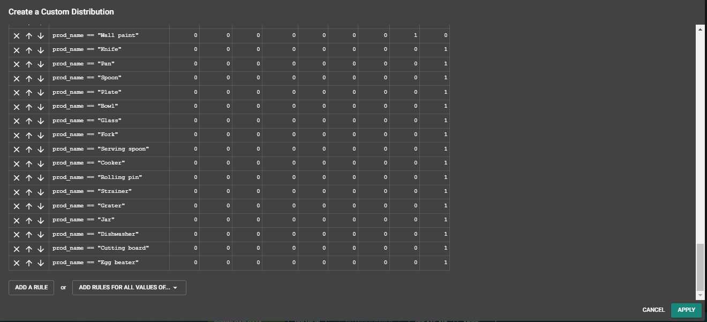

Inserting values into SVN_prod_dt

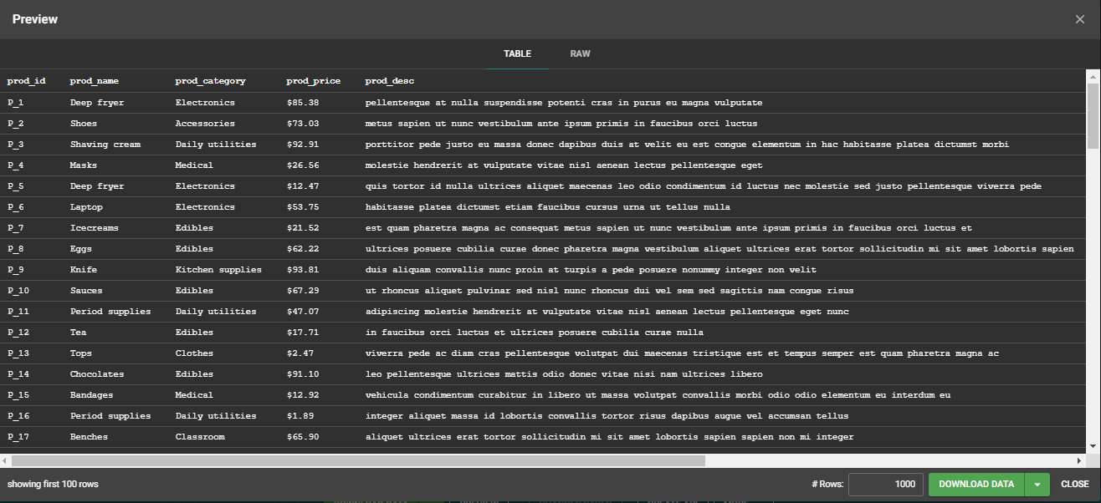

***SVN_staff_dt***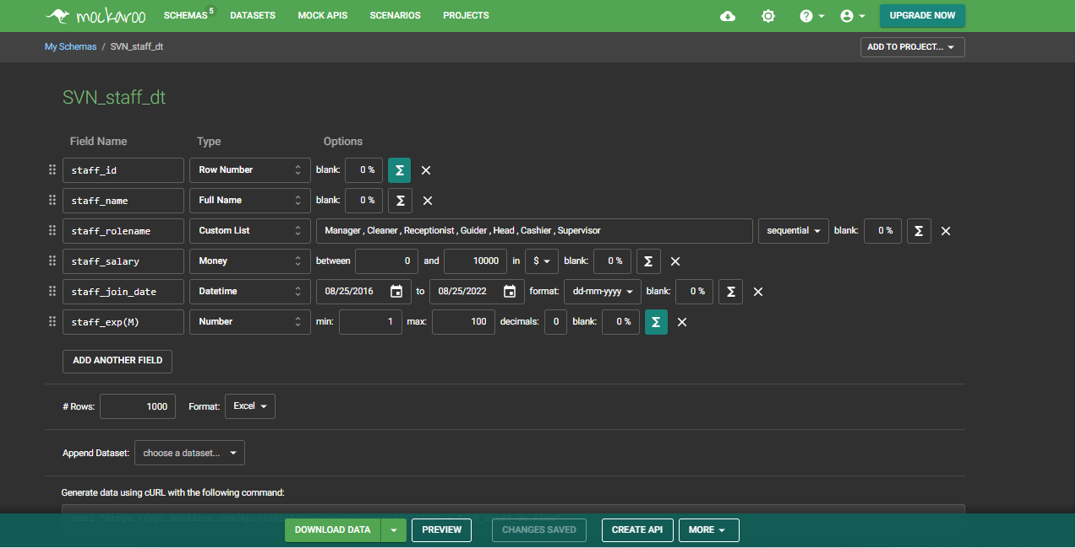

staff_rolename :

Manager , Cleaner , Receptionist , Guider , Head , Cashier , Supervisor

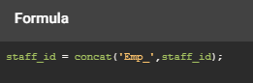



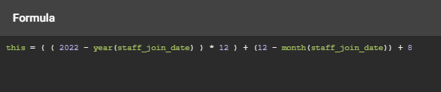

(this refers to staff exp(M) in months)

Inserting values into SVN_staff_dt

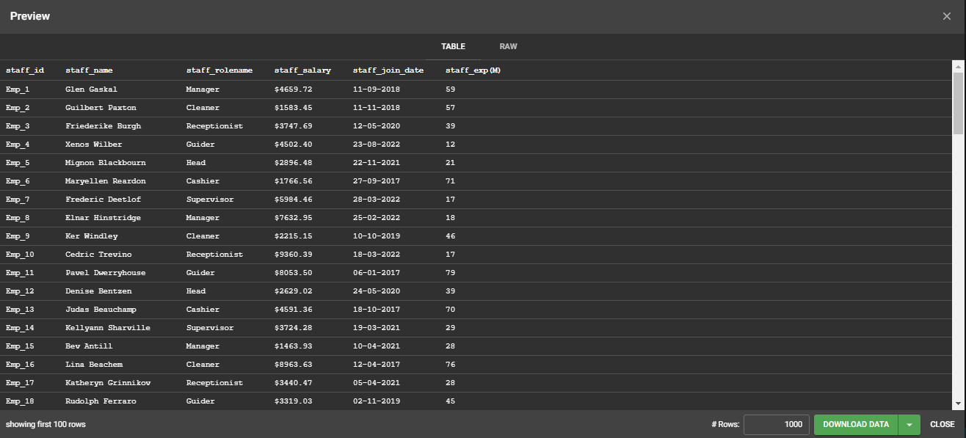

***SVN_store_dt***

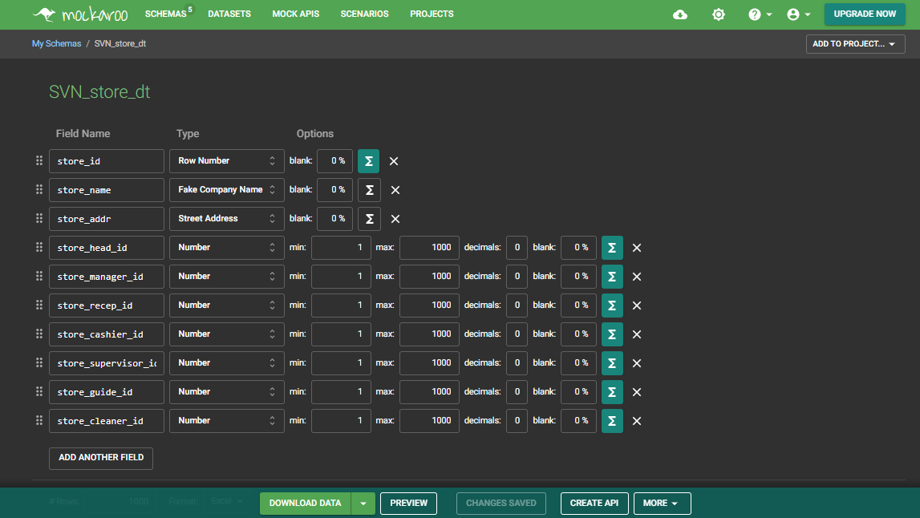

(here the staff of the store are supposed to be referencing the parent table SVN_staff_dt for the staff_id)

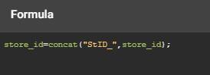



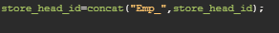

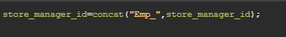

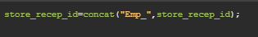



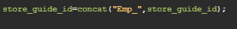

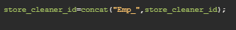



Inserting values into SVN_store_dt

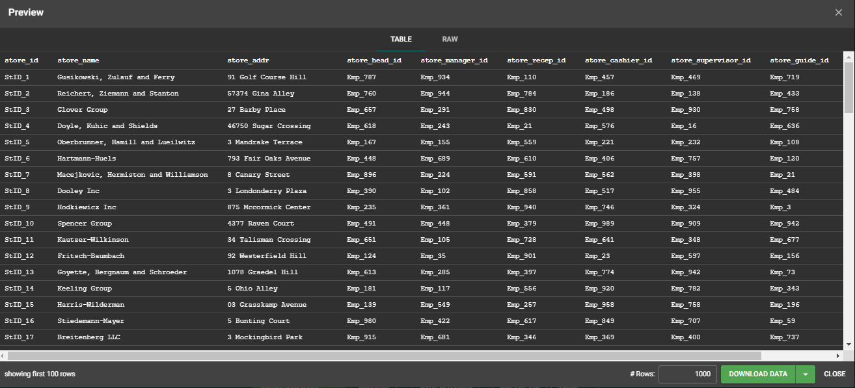

SVN_time_dt

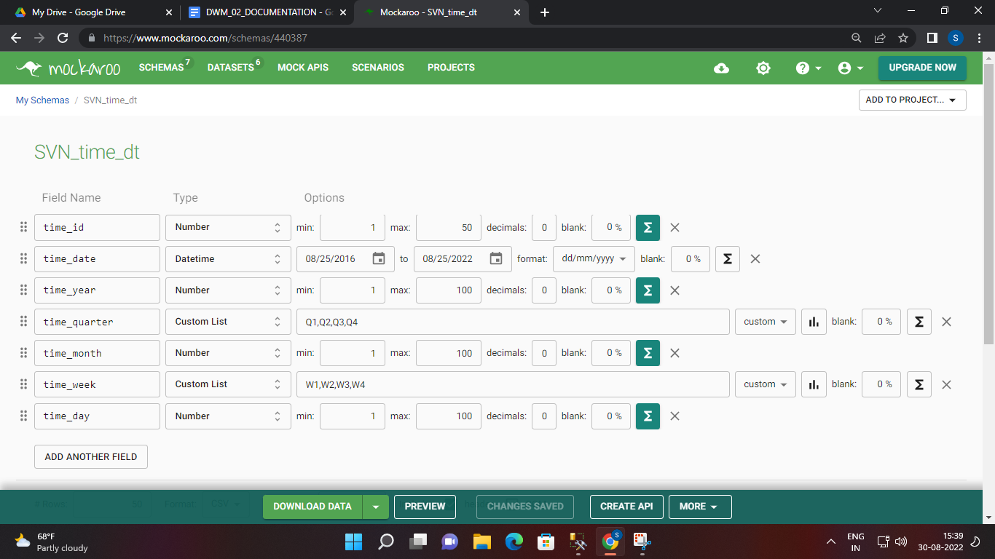

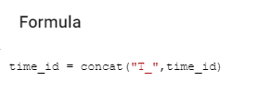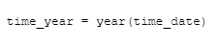

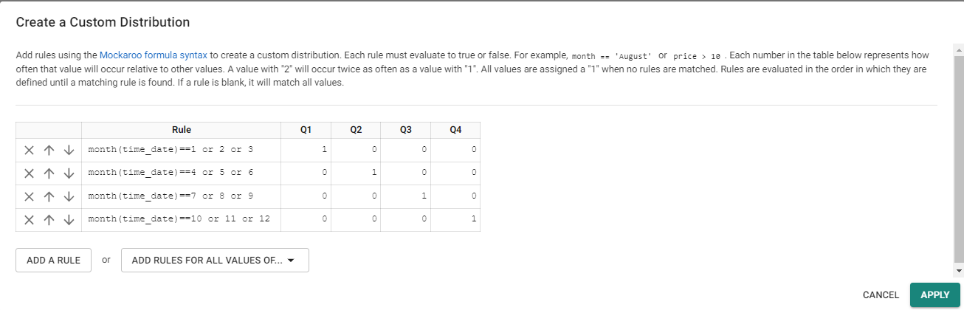

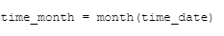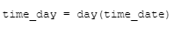

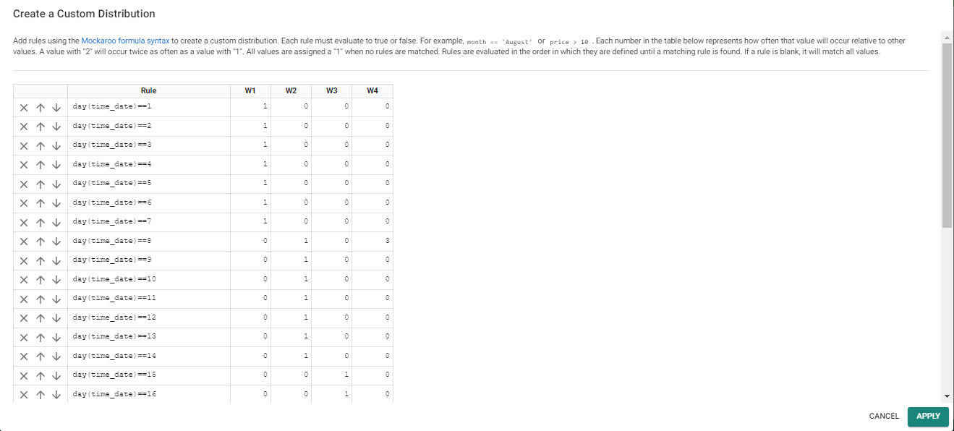

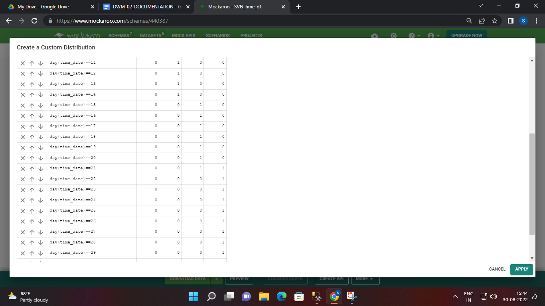

SVN_SALES_ANALYSIS_FT

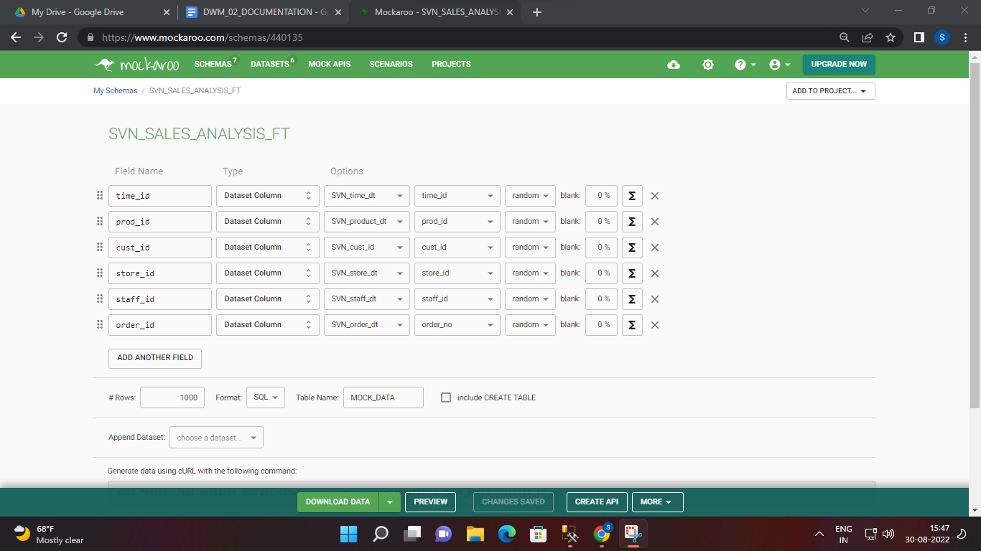

***SVN_order_dt***

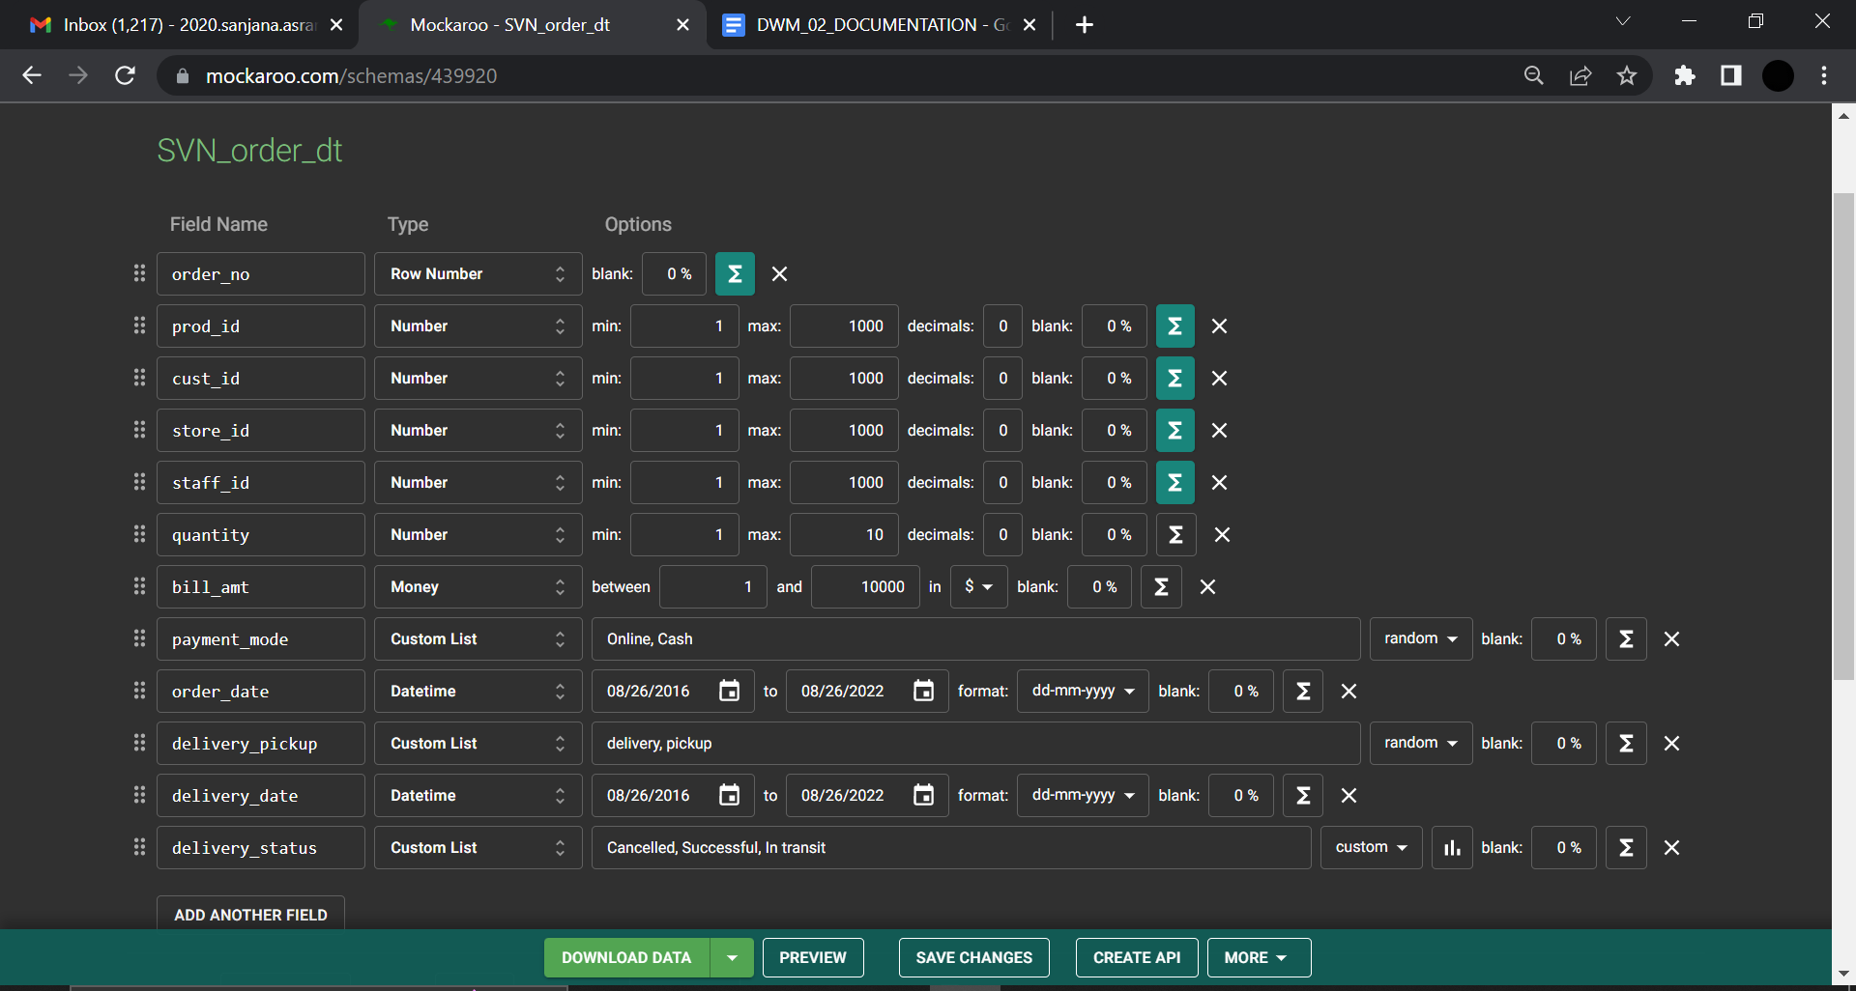

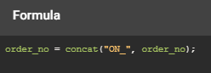

 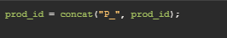

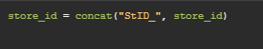 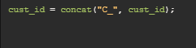

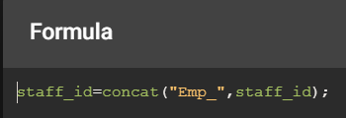

Custom distribution for delivery_status :

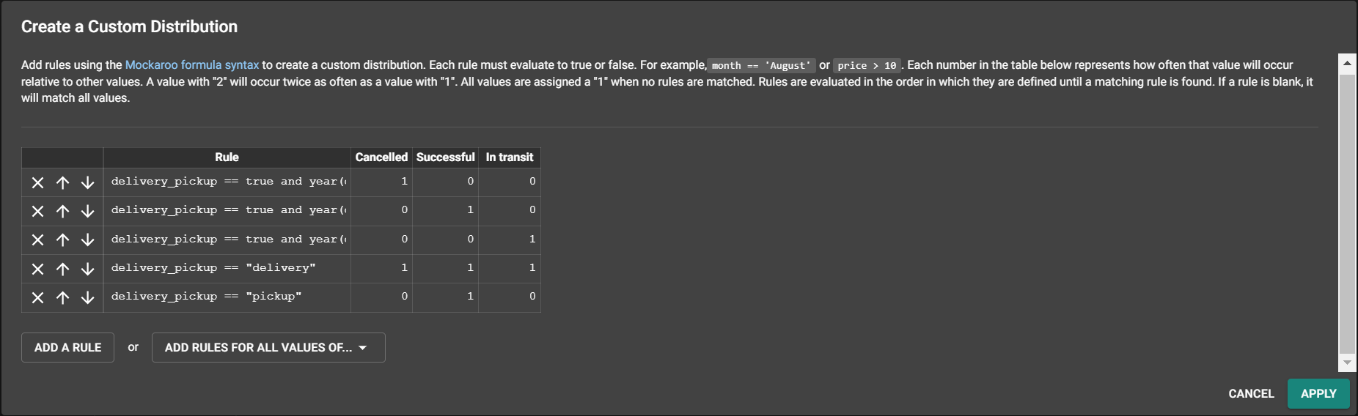

**Conditions** :

delivery_pickup == true and year(delivery_date) > year(order_date) and month(delivery_date) > month(order_date) and date(delivery_date) > date(order_date) : canceled

delivery_pickup == true and year(delivery_date) == year(order_date) and month(delivery_date) == month(order_date) and date(delivery_date) == date(order_date) : delivered

delivery_pickup == true and year(delivery_date) < year(order_date) and month(delivery_date) < month(order_date) and date(delivery_date) < date(order_date) : in transit

Inserting values into SVN_order_dt

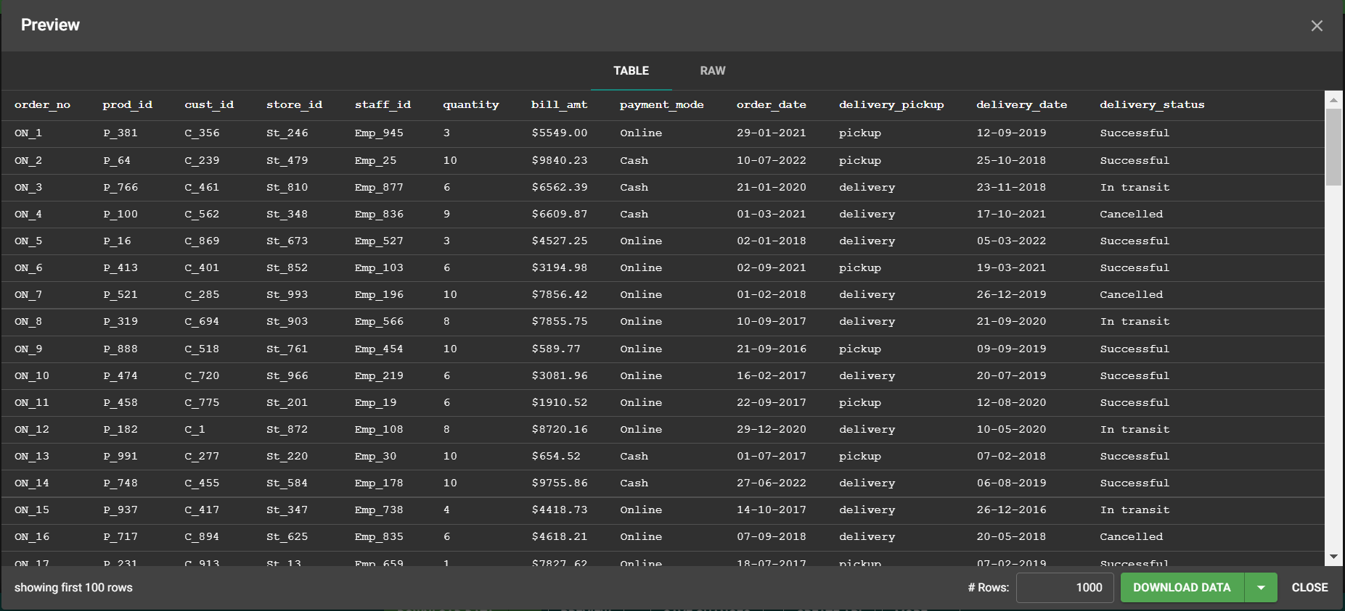

(here the staff_id are random and not referencing the parent table SVN_staff_dt ‘s staff_id)

**INSERTING FOREIGN KEYS IN SVN_order_dt**

**(keeping datatype of foreign key attribute as the dataset(values) of primary key attribute)**

Here prod_id , cust_id , store_id,staff_id are foreign keys referenced from SVN_prod_dt , SVN_cust_dt , SVN_store_dt,staff_id respectively.

Search for prod_id in the datatype for fk prod_id

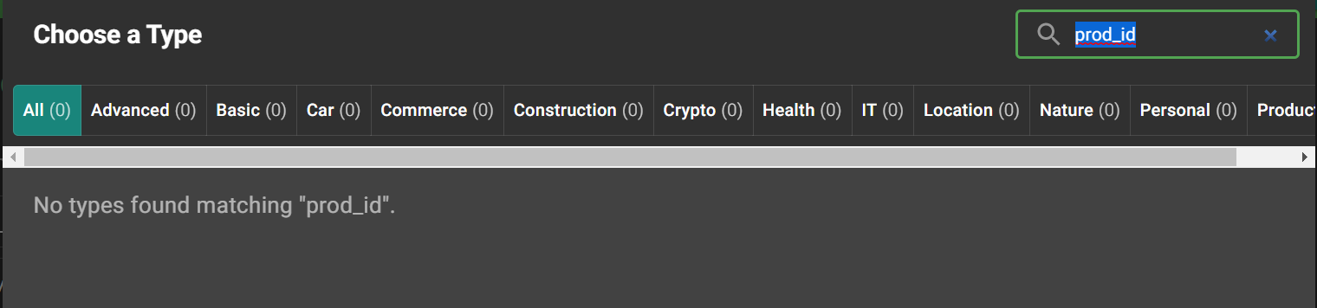

Before dataset from pk table SVN_prod_dt was downloaded

1. Create dataset of primary key table after selecting csv

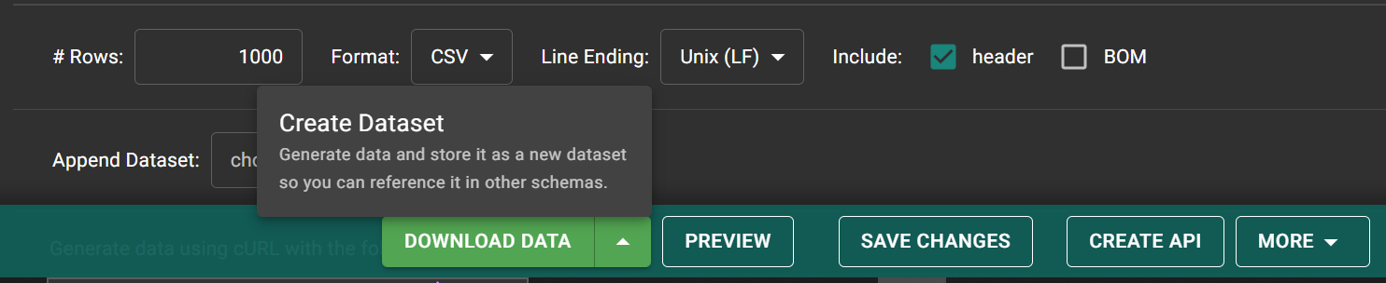

Creating dataset from pk table

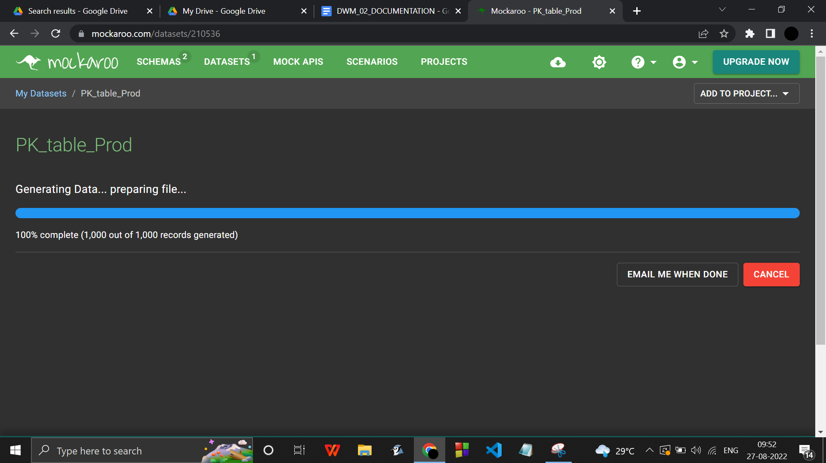

In process of creating the dataset

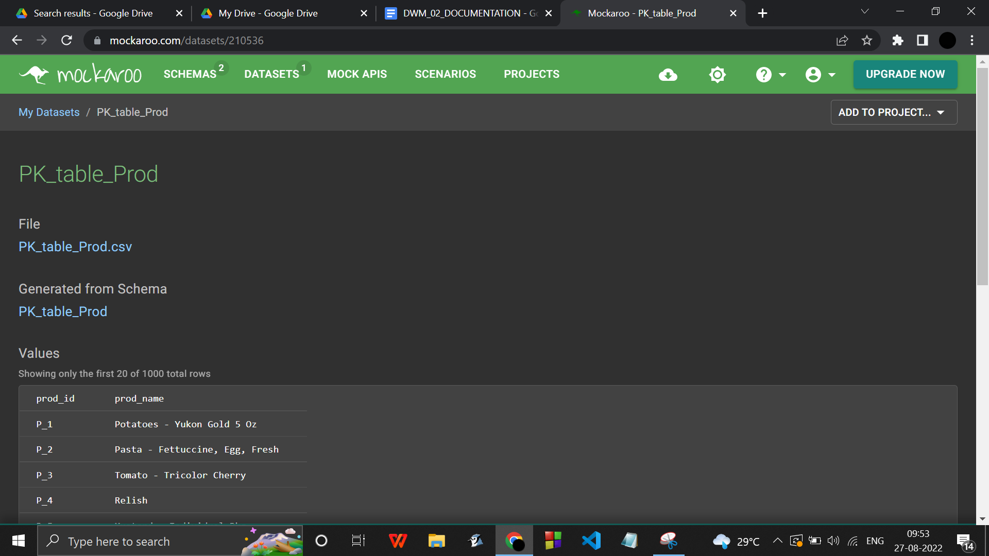

After the dataset has been downloaded

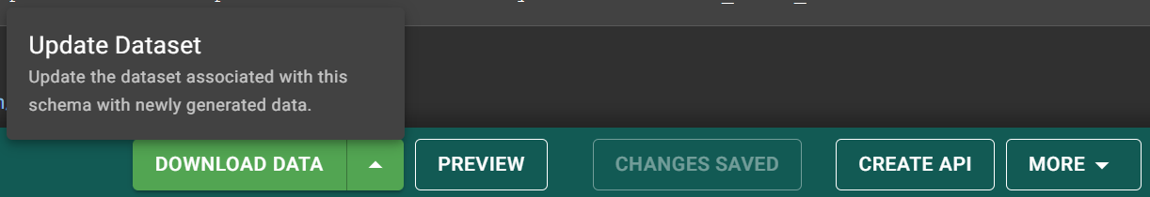

Updating the PK table dataset

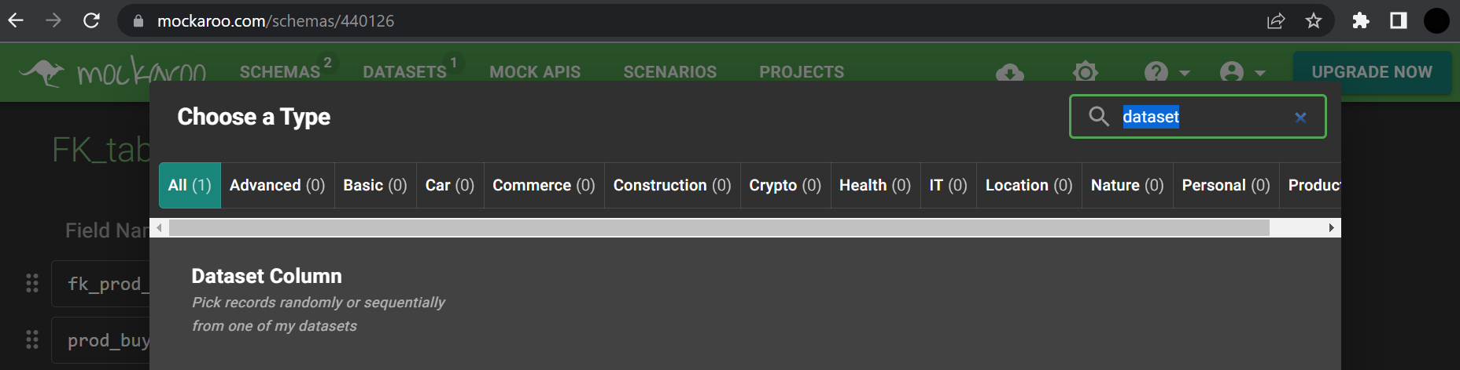

Select dataset column in datatype of required foreign key

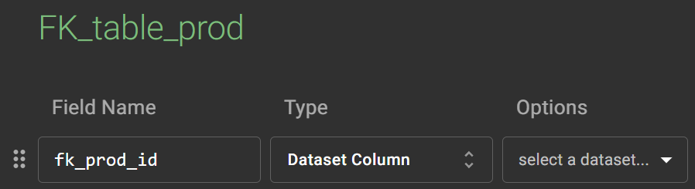

Select suitable parent table and primary key reference.

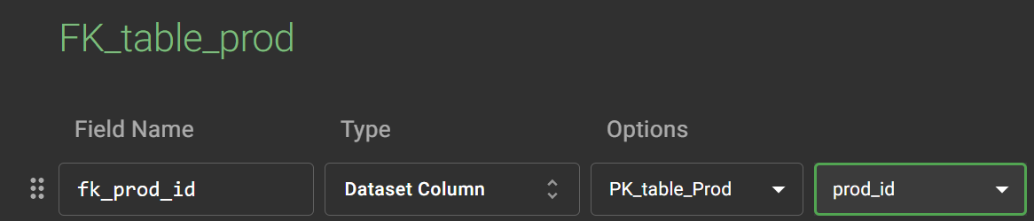

Linking with the parent table has been done .

Similarly , do it for prod, cust , store, staff table as well.

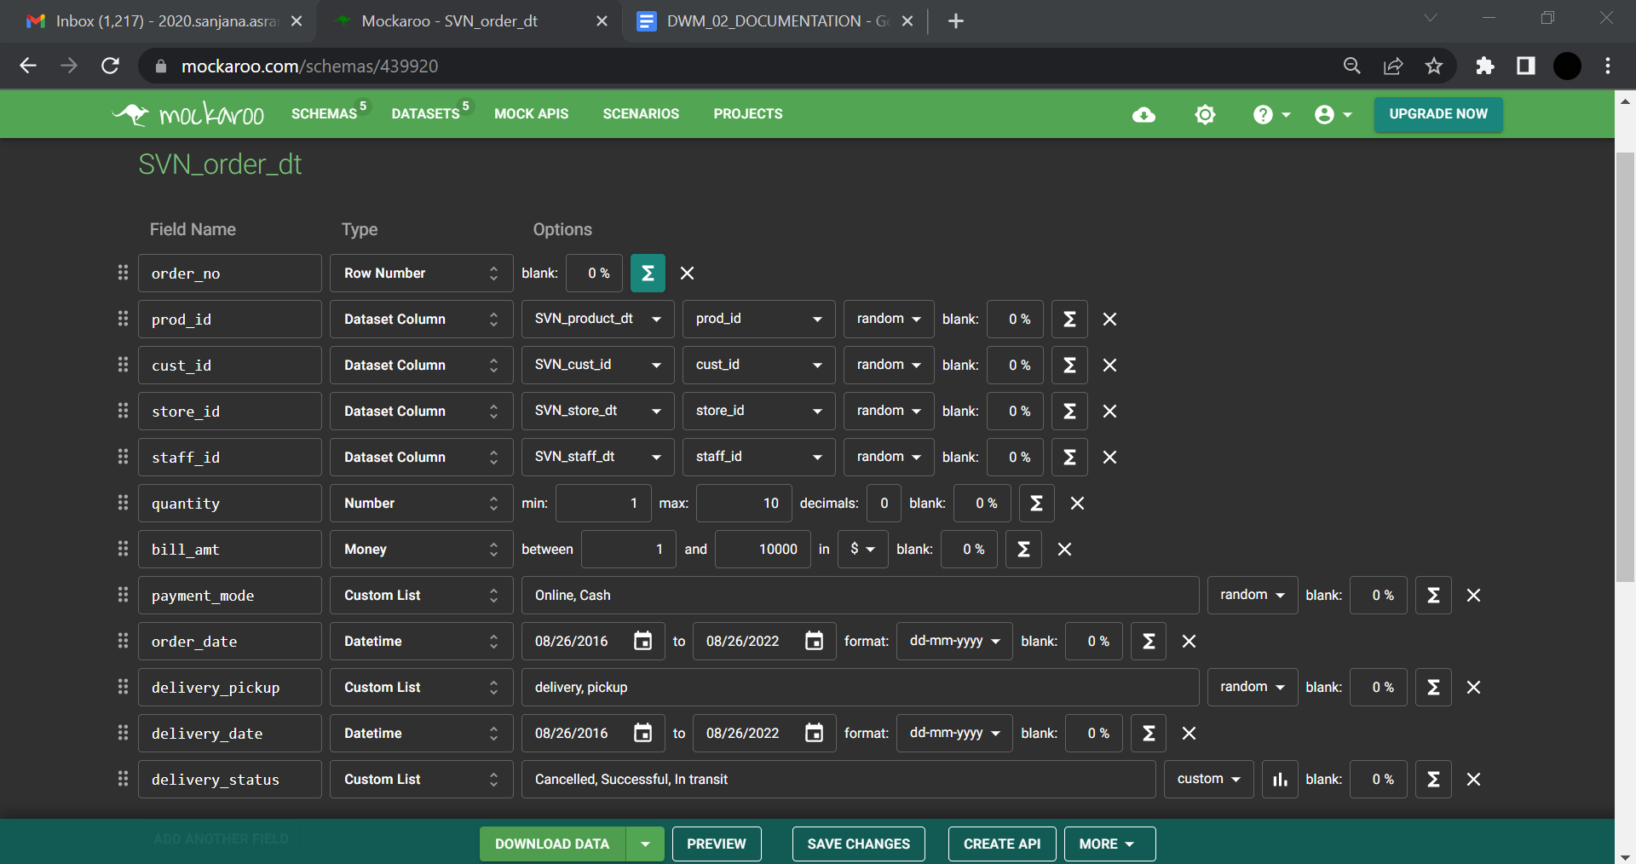

**CREATING SVN_SALES_ANALYSIS_FT**

Select respective parent tables for all attributes since all of them are foreign keys .

For eg. SVN_product_dt table’s prod_id for prod_id

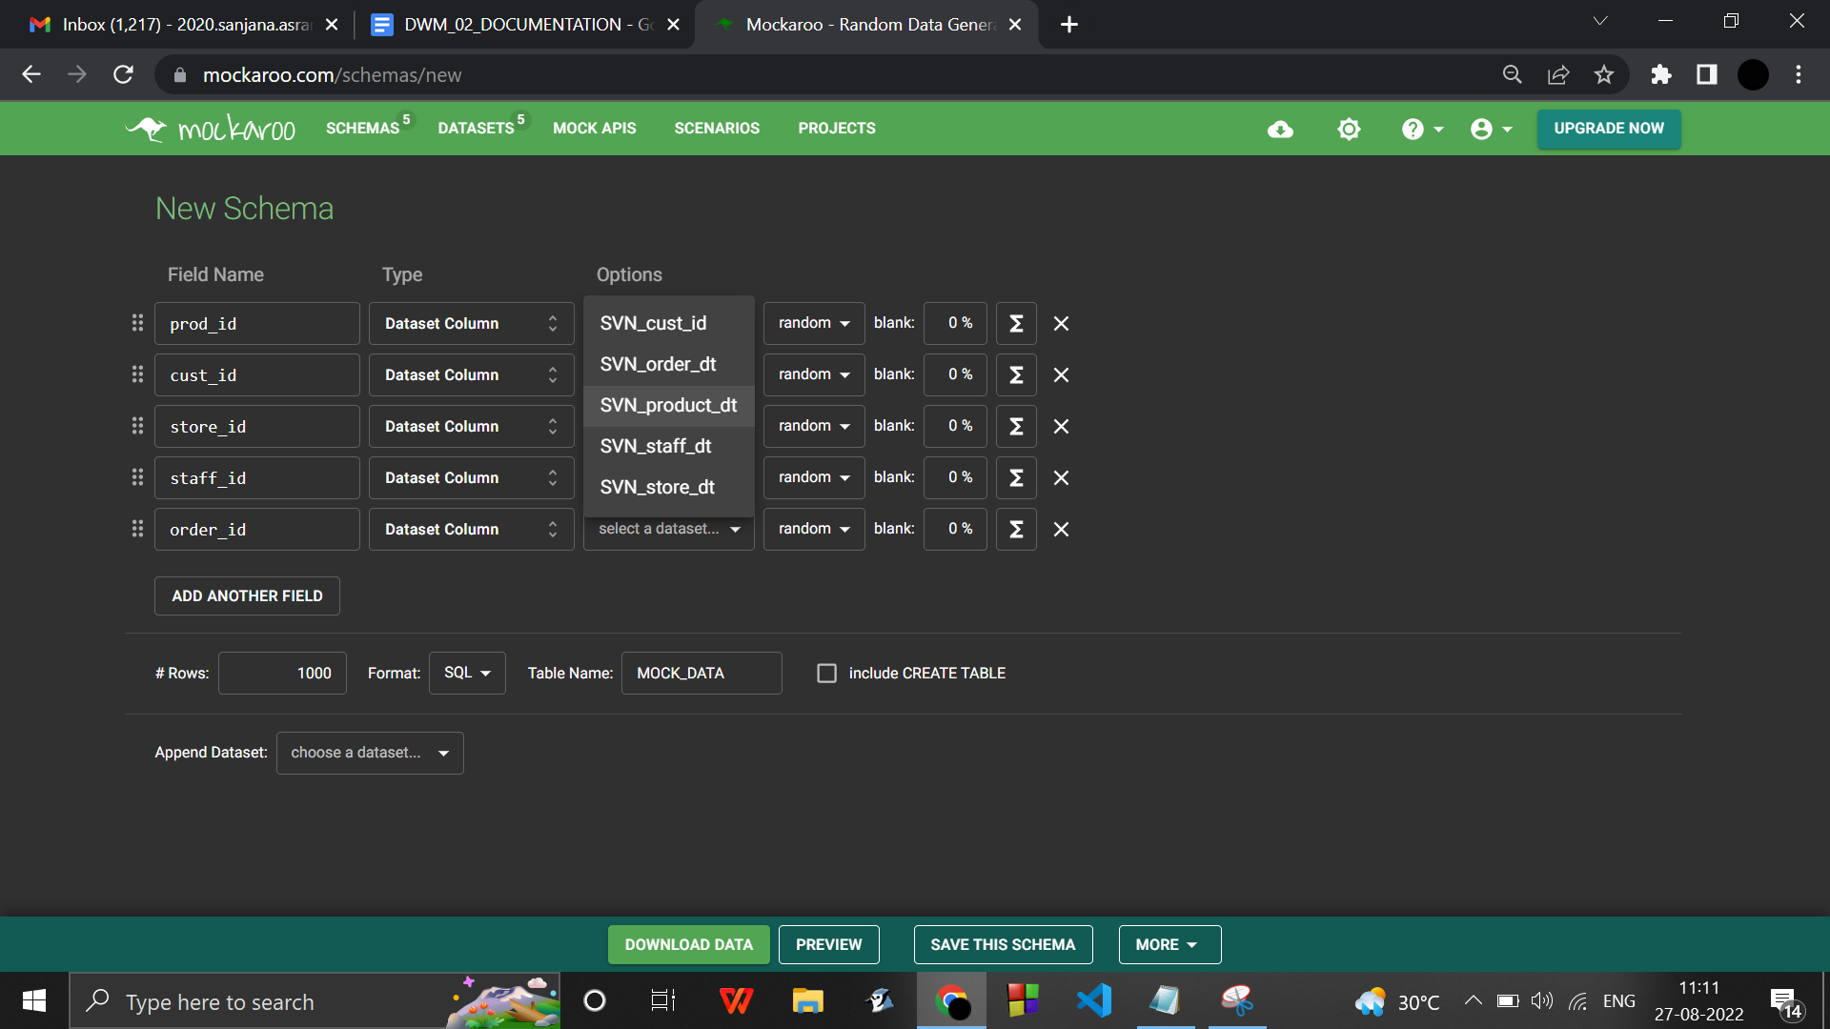

**After selecting all the datatypes / creating foreign keys :**

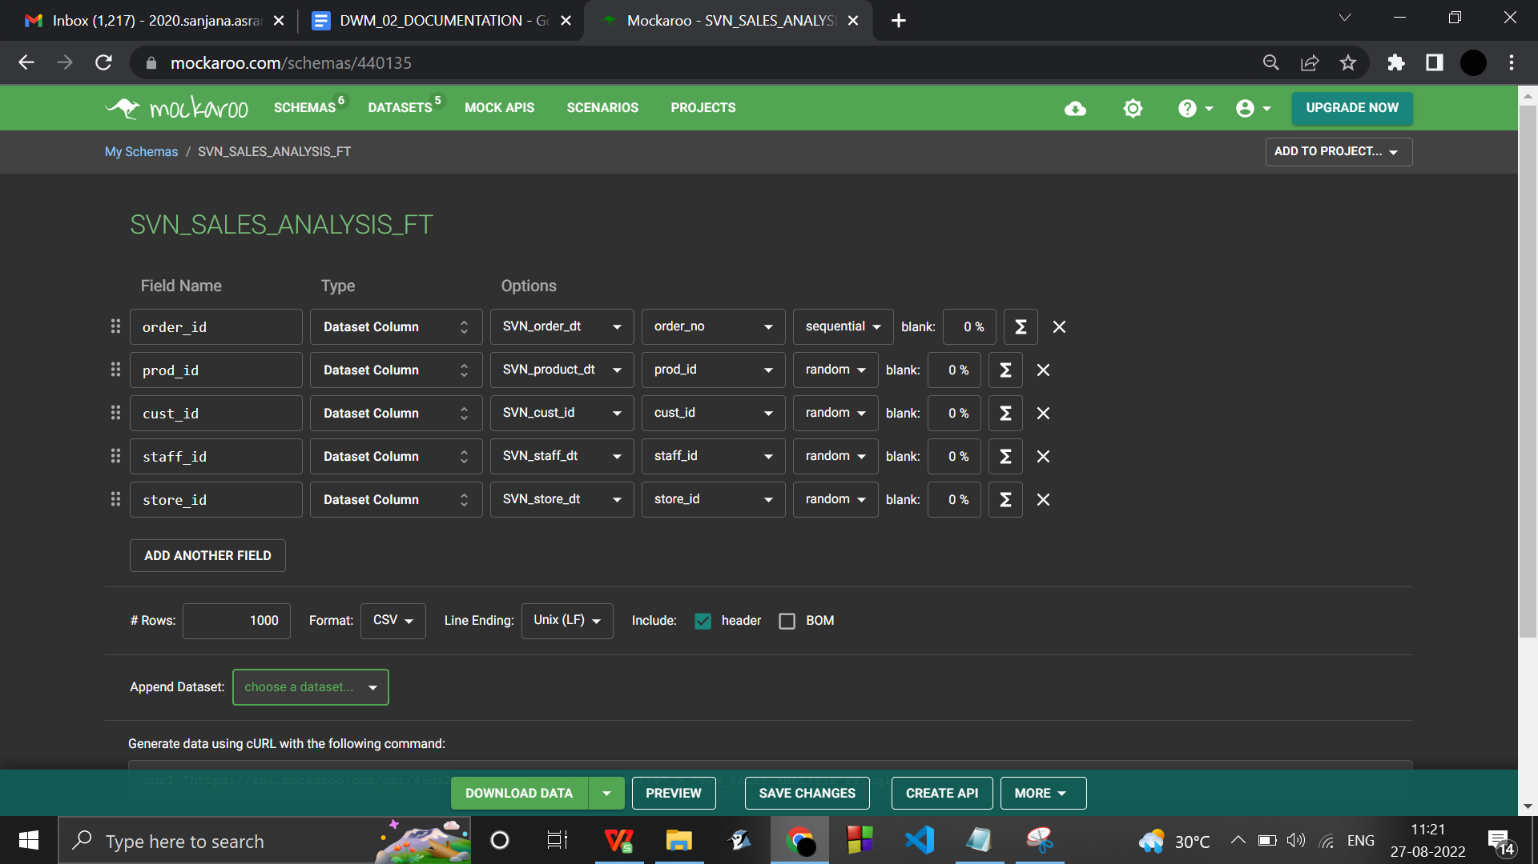

**Preview :**

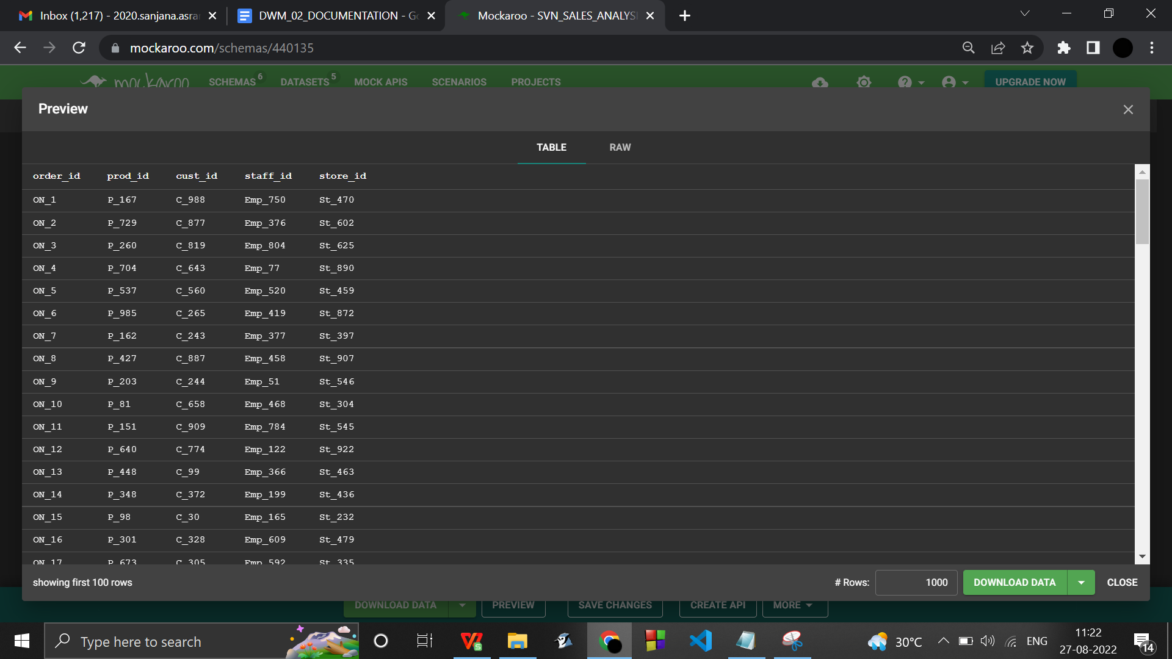

**SQL COMMANDS**

**PROD …no fk**

**STAFF …no fk**

**STORE …no fk**

**CUSTOMER …no fk**

**ORDER .. fk of prod,staff,store,customer**

1. **DDL CREATE TABLE**

create table SVN_prod_dt (

prod_id PRIMARY KEY,

prod_name VARCHAR(17),

prod_category VARCHAR(16),

prod_price VARCHAR(50),

prod_desc TEXT,

prod_in_stock_amt INT,

prod_reqd_amt INT,

prod_restock_date DATE,

prod_supplier VARCHAR(50)

);

create table SVN_staff_dt (

staff_id PRIMARY KEY,

staff_name VARCHAR(50),

staff_rolename VARCHAR(12),

staff_salary VARCHAR(50),

staff_join_date DATE,

staff_exp(M) INT

);

create table SVN_store_dt (

store_id PRIMARY KEY,

store_name VARCHAR(50),

store_addr VARCHAR(50),

store_head_id VARCHAR FOREIGN KEY REFERENCES SVN_staff_dt (staff_id),

store_manager_id VARCHAR FOREIGN KEY REFERENCES SVN_staff_dt (staff_id),

store_recep_id VARCHAR FOREIGN KEY REFERENCES SVN_staff_dt (staff_id),

store_cashier_id VARCHAR FOREIGN KEY REFERENCES SVN_staff_dt (staff_id),

store_supervisor_id VARCHAR FOREIGN KEY REFERENCES SVN_staff_dt (staff_id),

store_guide_id VARCHAR FOREIGN KEY REFERENCES SVN_staff_dt (staff_id),

store_cleaner_id VARCHAR FOREIGN KEY REFERENCES SVN_staff_dt (staff_id)

);

create table SVN_cust_dt (

cust_id PRIMARY KEY,

cust_name VARCHAR(50),

cust_dob DATE,

cust_age INT,

cust_gender VARCHAR(50),

cust_addr VARCHAR(50),

cust_balance_due VARCHAR(50),

cust_phone_no VARCHAR(50)

);

create table SVN_order_dt (

order_no PRIMARY KEY,

quantity INT,

bill_amt VARCHAR(50),

payment_mode VARCHAR(6),

order_date DATE,

delivery_pickup VARCHAR(8),

delivery_date DATE,

delivery_status VARCHAR(10),

prod_id VARCHAR FOREIGN KEY REFERENCES SVN_prod_dt (prod_id) ,

cust_id VARCHAR FOREIGN KEY REFERENCES SVN_cust_dt (cust_id),

store_id VARCHAR FOREIGN KEY REFERENCES SVN_store_dt (store_id),

//staff_id VARCHAR FOREIGN KEY REFERENCES SVN_staff_dt (staff_id)

);

create table SVN_SALES_ANALYSIS_FT(

order_id VARCHAR FOREIGN KEY REFERENCES SVN_order_dt (order_no)

prod_id VARCHAR FOREIGN KEY REFERENCES SVN_prod_dt (prod_id) ,

cust_id VARCHAR FOREIGN KEY REFERENCES SVN_cust_dt (cust_id),

//staff_id VARCHAR FOREIGN KEY REFERENCES SVN_staff_dt (staff_id),

store_id VARCHAR FOREIGN KEY REFERENCES SVN_store_dt (store_id),

Unit_sales NUMBER,

Weekly_prodcat_sales NUMBER,

yearly_prod_city_salesNUMBER

);

create table SVN_time_dt(

time_id PRIMARY KEY,

time_date DATE,

time_year INT,

time_quarter VARCHAR(2),

time_month INT,

time_week VARCHAR(2),

time_day INT

);

1. **DML**

insert into **SVN_prod_dt** (prod_id, prod_name, prod_category, prod_price, prod_desc, prod_in_stock_amt, prod_reqd_amt, prod_restock_date, prod_supplier) values ('P_1', 'Strainer', 'Kitchen supplies', '$86.77', 'ullamcorper augue a suscipit nulla elit ac nulla sed vel enim sit amet nunc viverra dapibus nulla', 21, 42, '11/09/2020', 'Lueilwitz Group');

insert into **SVN_staff_dt** (staff_id, staff_name, staff_rolename, staff_salary, staff_join_date, staff_exp(M)) values ('Emp_1', 'Henry Lindenbluth', 'Manager', '$9196.52', '14-06-2019', 50);

insert into **SVN_store_dt** (store_id, store_name, store_addr, store_head_id, store_manager_id, store_recep_id, store_cashier_id, store_supervisor_id, store_guide_id, store_cleaner_id) values ('St_1', 'Shields-Morar', '9713 Roth Street', 'Emp_146', 'Emp_550', 'Emp_827', 'Emp_293', 'Emp_922', 'Emp_522', 'Emp_993');

insert into **SVN_cust_dt** (cust_id, cust_name, cust_dob, cust_age, cust_gender, cust_addr, cust_balance_due, cust_phone_no) values ('C_1', 'Isaac Yelland', '25-05-1988', 34, 'Male', '4966 Elka Parkway', '$3.72', '806-981-6340');

insert into **SVN_order_dt** (order_no, prod_id, cust_id, store_id, quantity, bill_amt, payment_mode, order_date, delivery_pickup, delivery_date, delivery_status) values ('ON_1', 'P_10', 'C_52', 'St_902', 5, '$7202.60', 'Online', '04-07-2022', 'pickup', '06-01-2021', 'Successful');

insert into **SVN_SALES_ANALYSIS_FT**(order_id, prod_id, cust_id, staff_id, store_id) values ('ON_1', 'P_594', 'C_393', 'Emp_477', 'St_976');

……………………………………………………………………………………………………….

ALL SCHEMAS : DIMENSION TABLES ALONG WITH FACT TABLES :

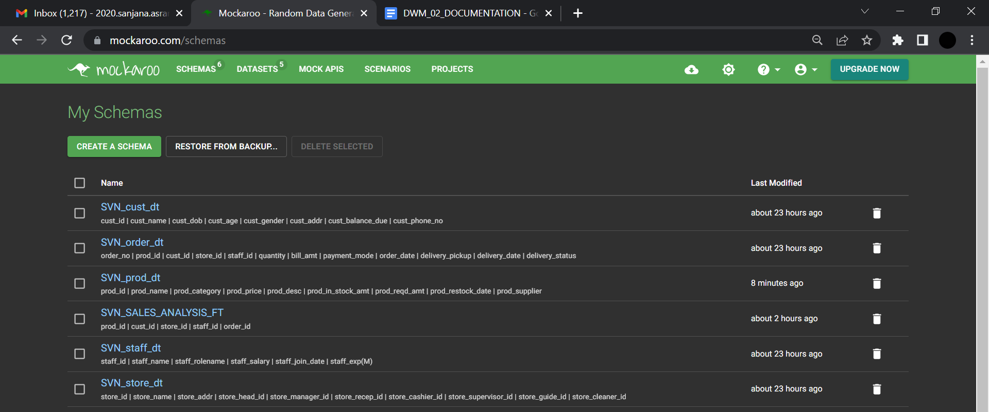

……………………………………………………………………………………………………….

**IMPORTING THE DATASETS INTO SQL OLE DB MANAGEMENT SYSTEM**

Download the dataset as csv

Go to the database

Tasks

Import data

Flat file source ,

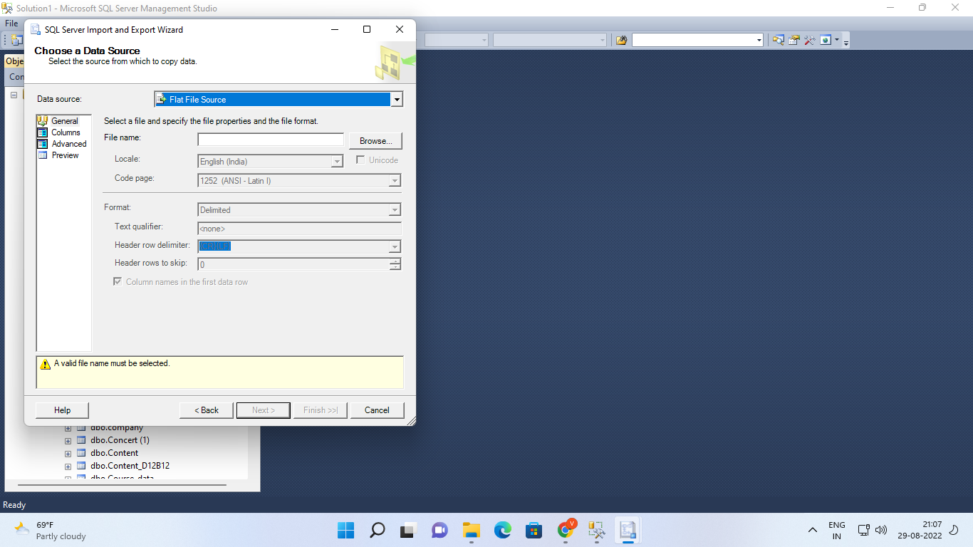

browse the file

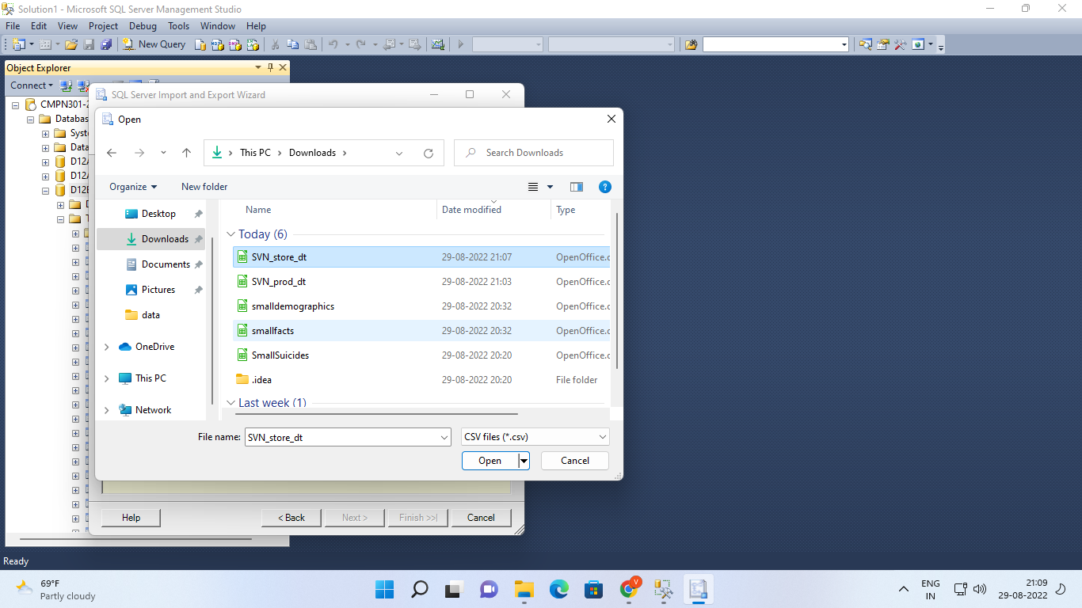

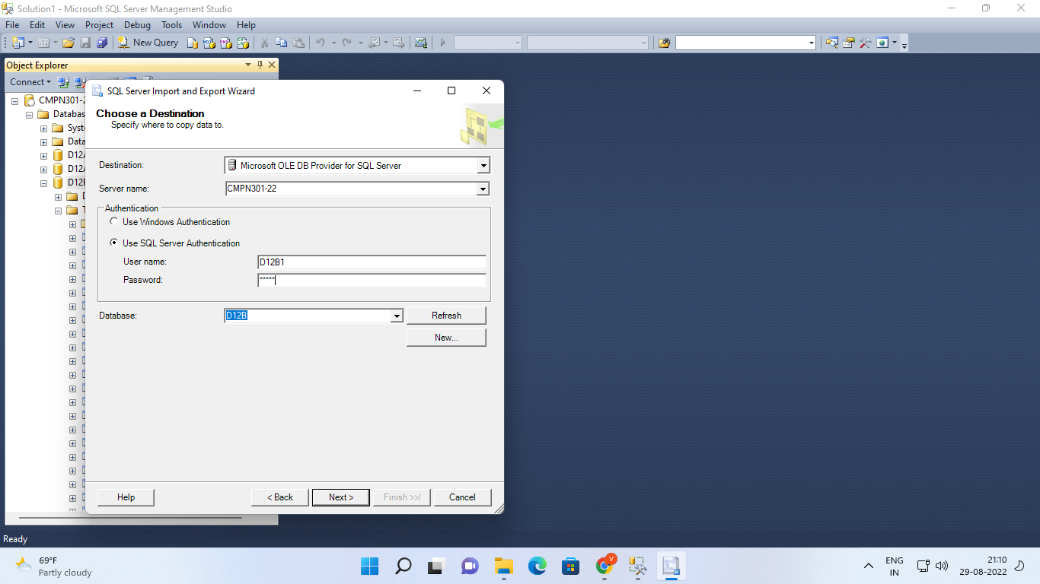

CLICK ON NEXT :

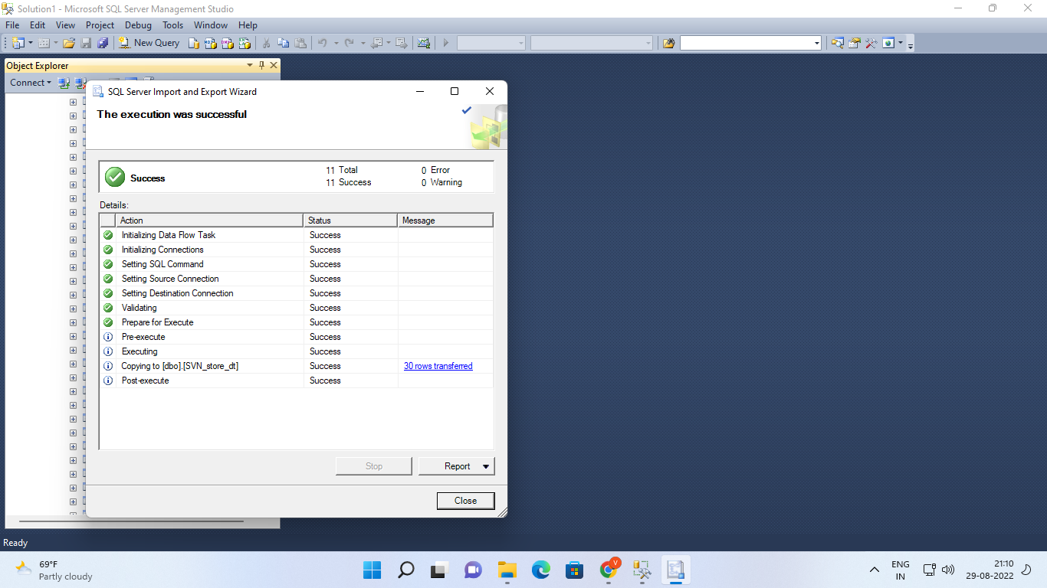

…………………………………………

Right click on the imported dimension table :

1. Script table as : CREATE to : new query editor window

: SELECT to : new query editor window

: INSERT to : new query editor window

1. SELECT top 200 rows
2. Script table as

CREATE to

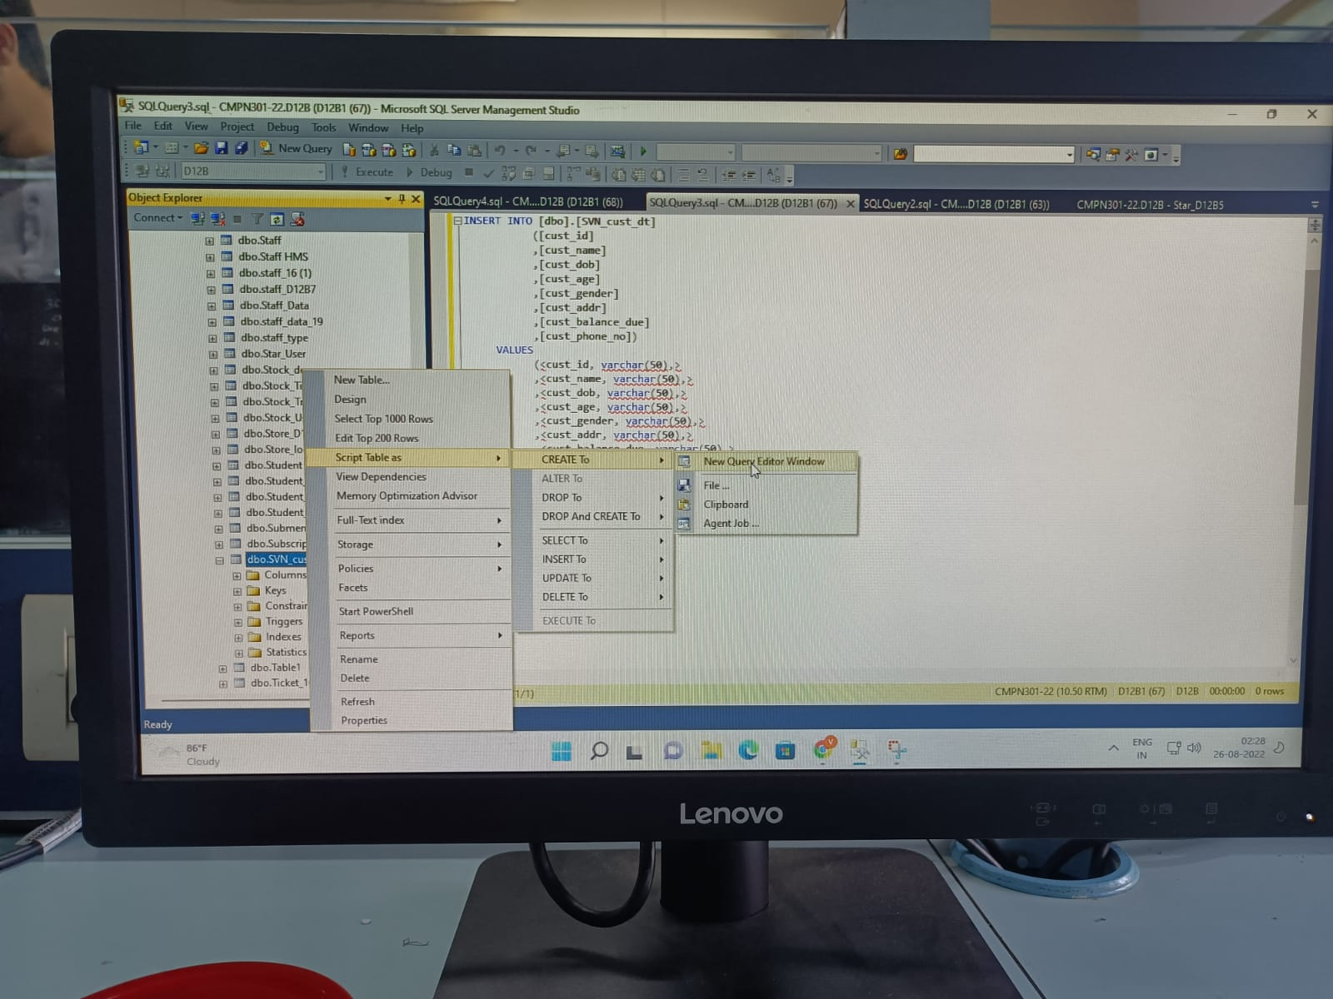

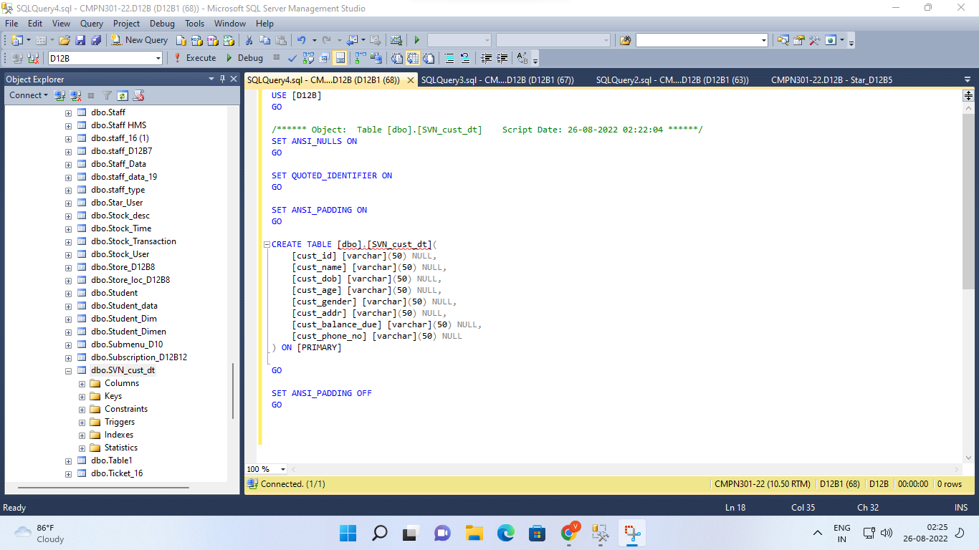

SELECT to

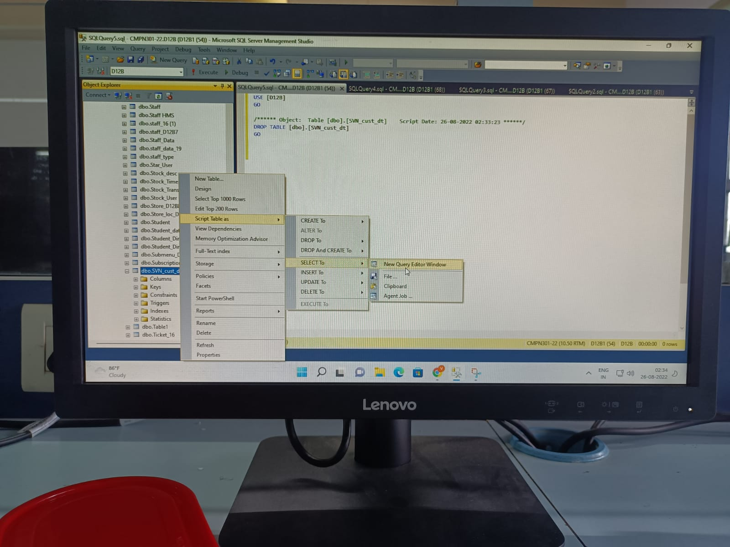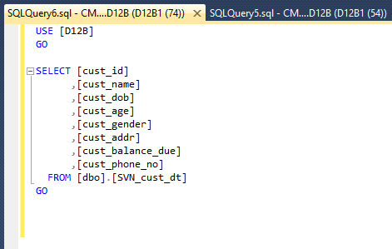

INSERT to

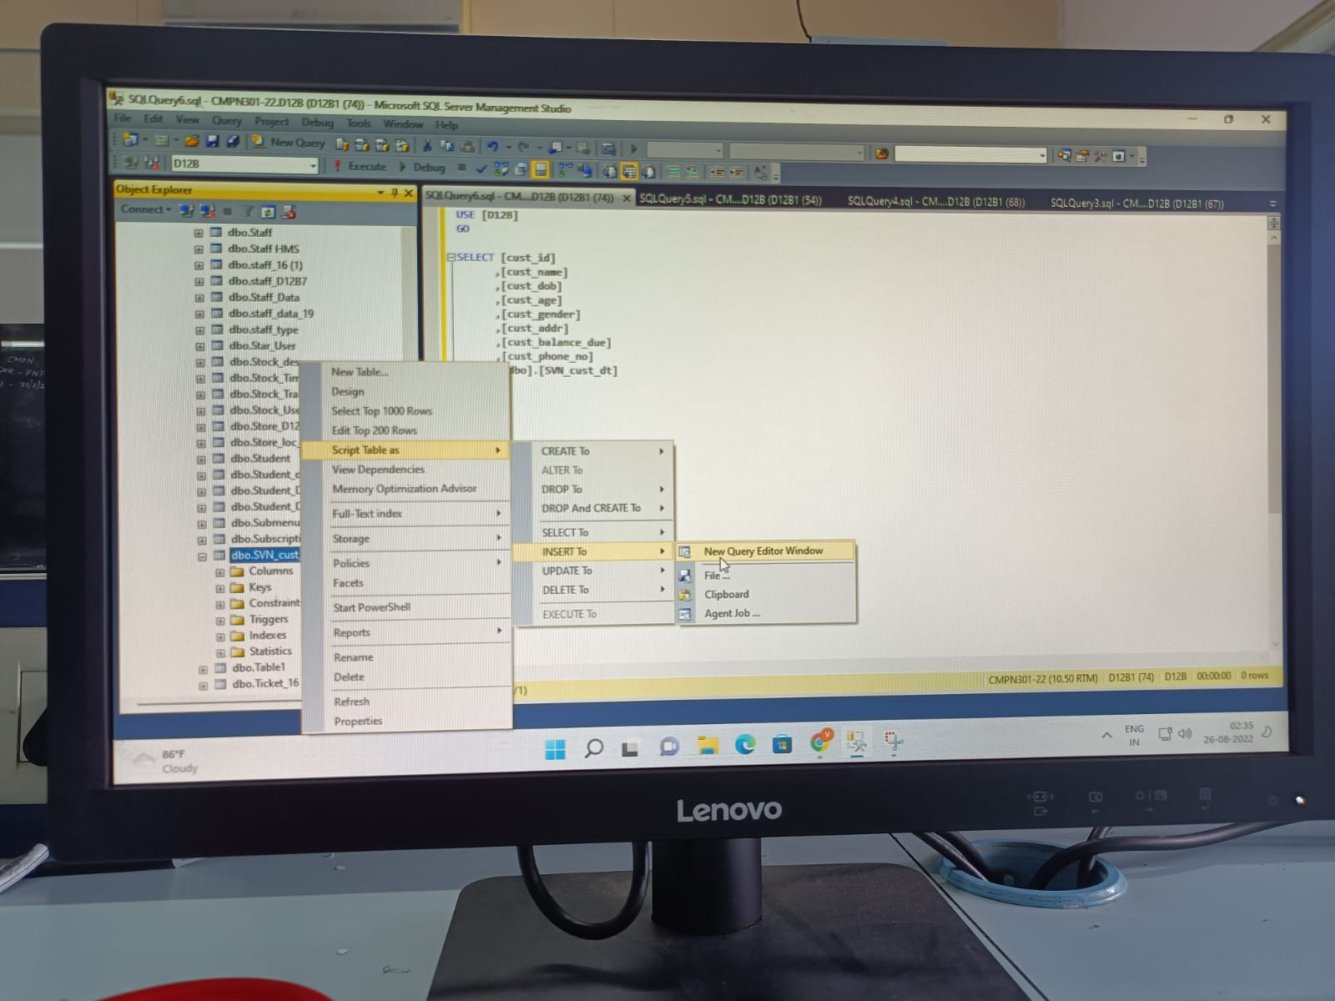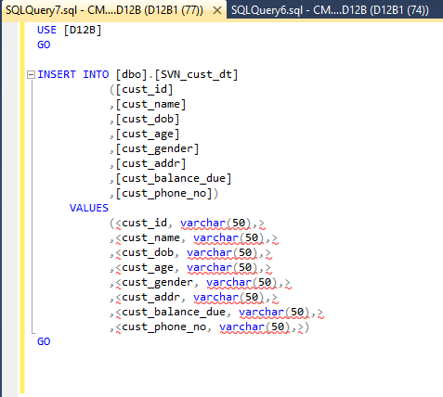

2. SELECT TOP 1000 ROWS

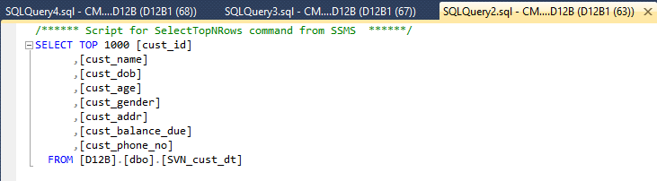

**CREATING SCHEMA DIAGRAMS FOR OUR ERD**

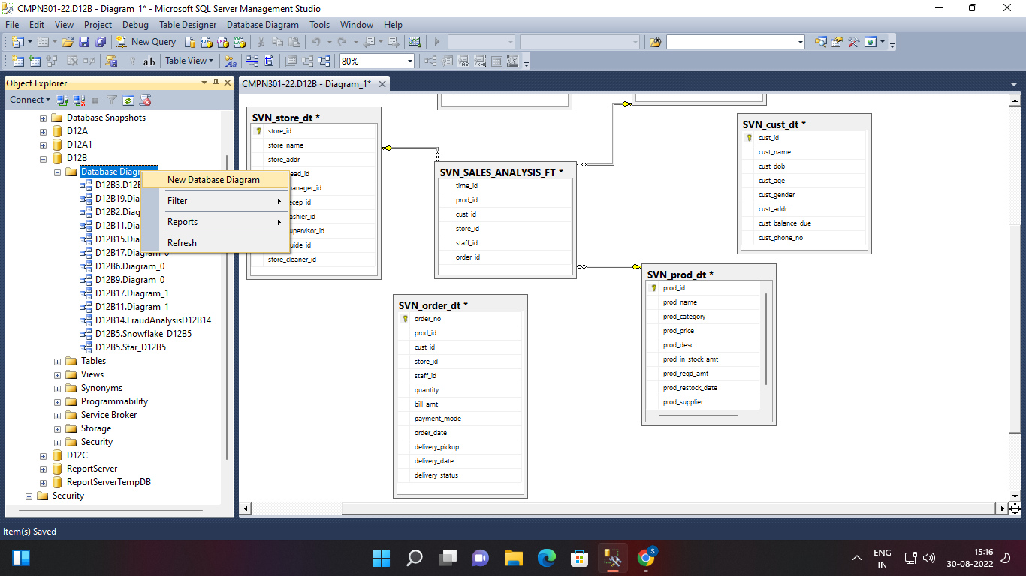

**Add the tables**

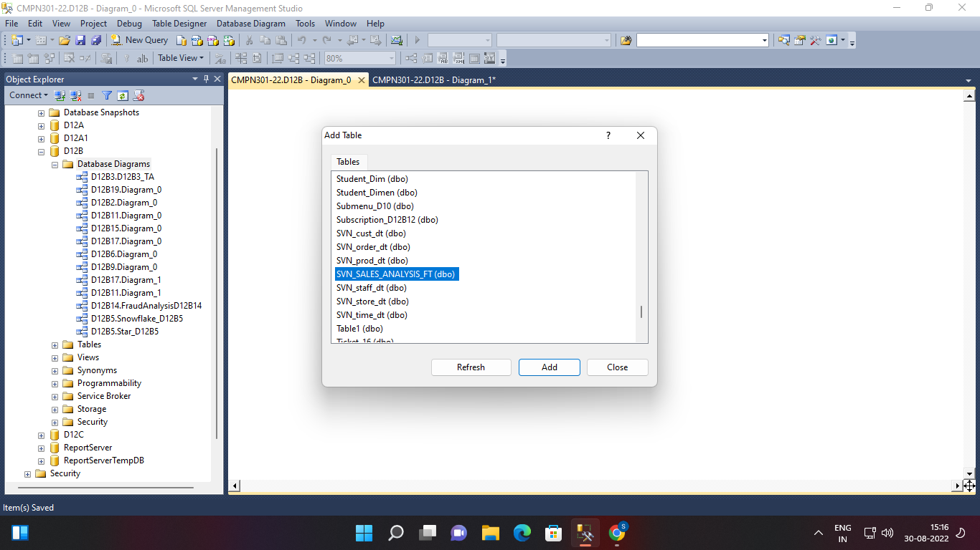

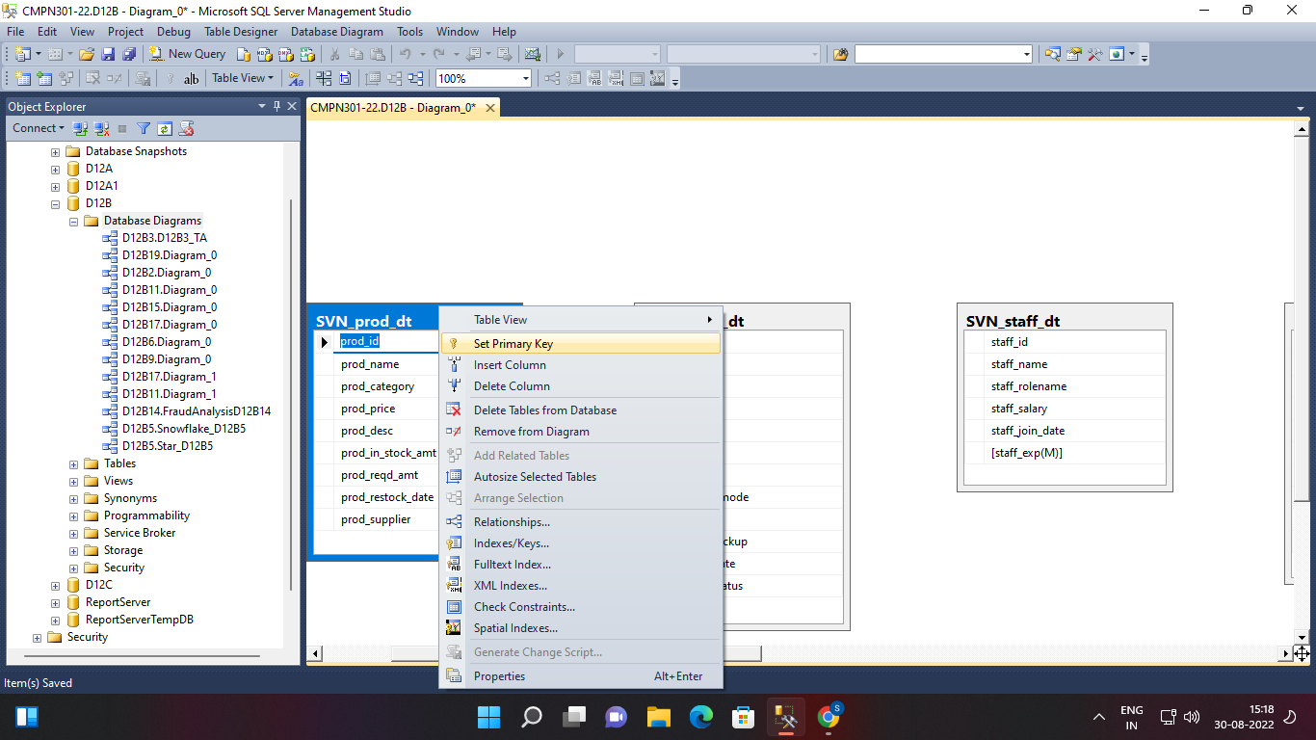

**Set primary keys in each table**

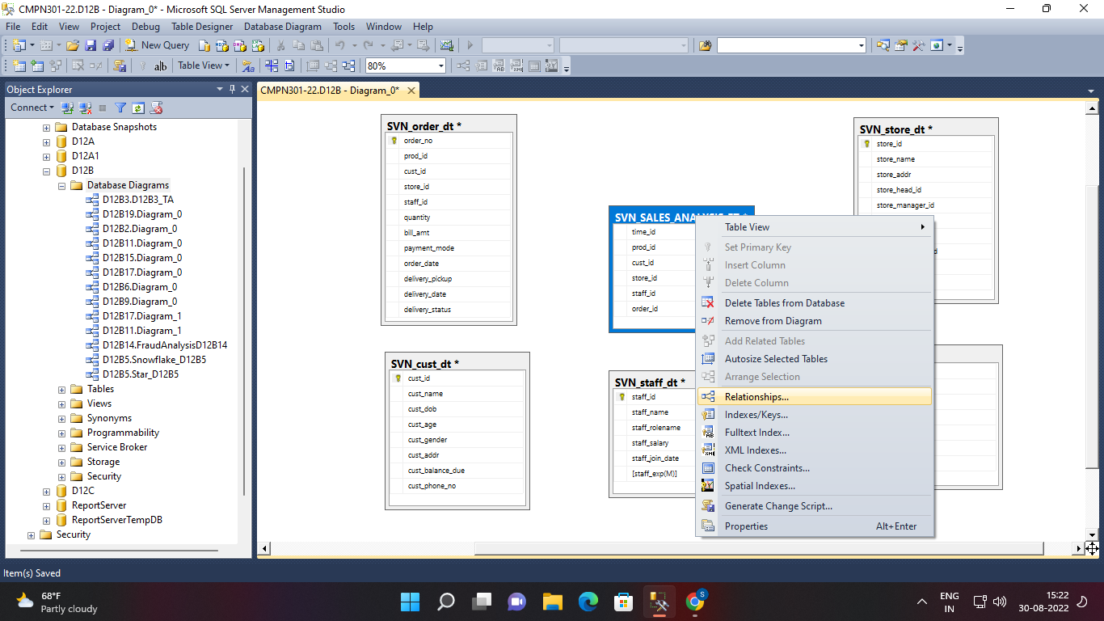

**Right click on ft and click on relationships**

**Click on add**

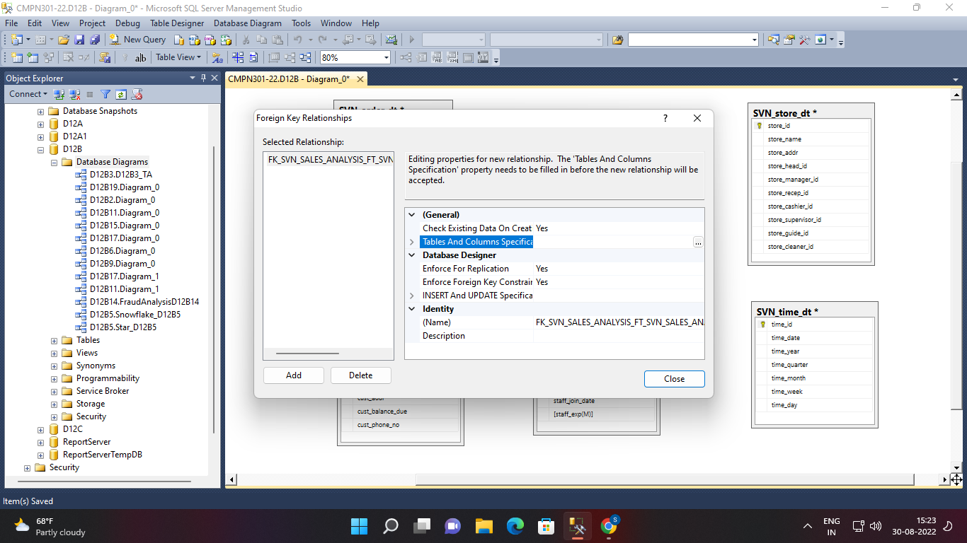

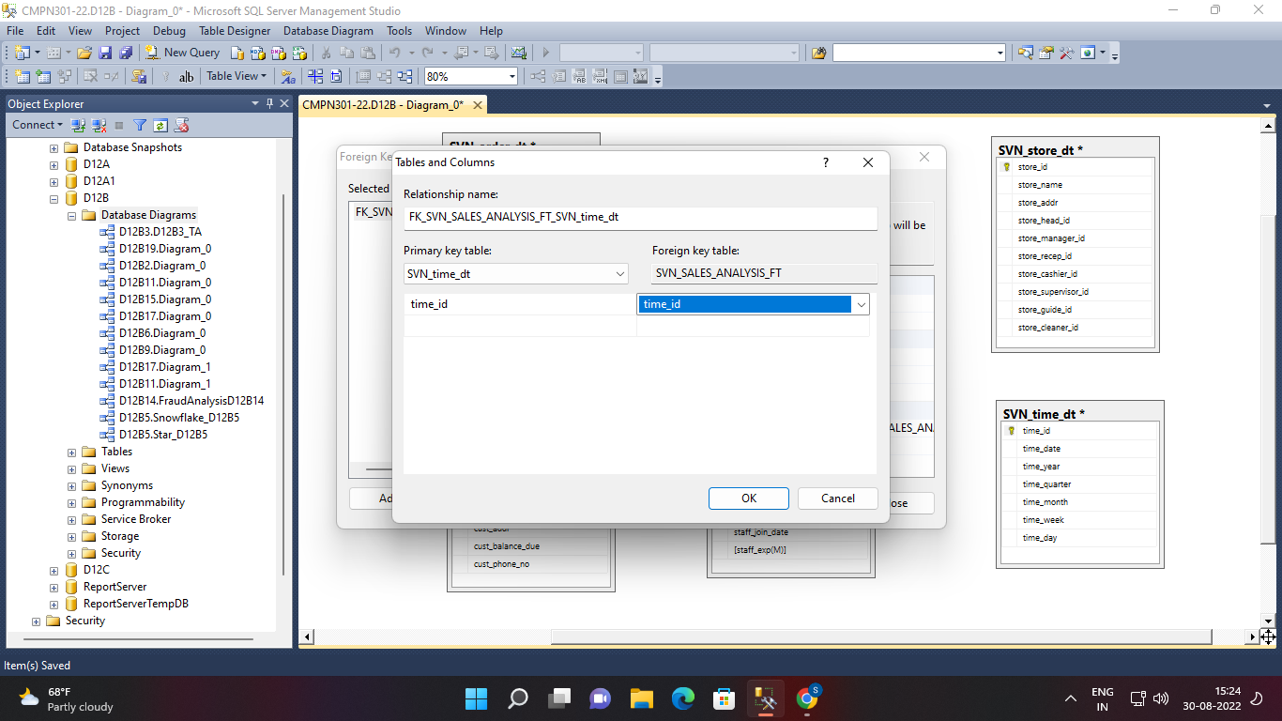

**Similarly do it for all keys**

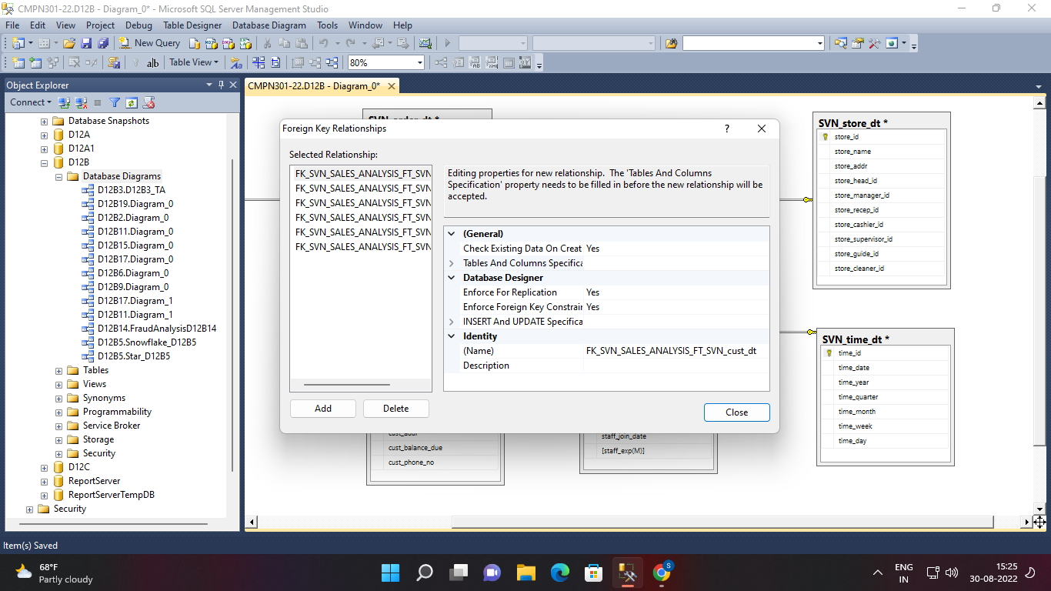

**Done**

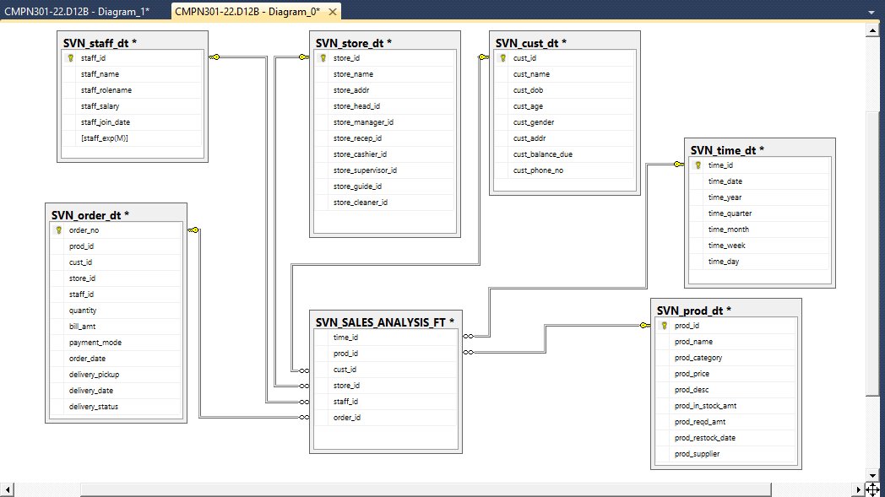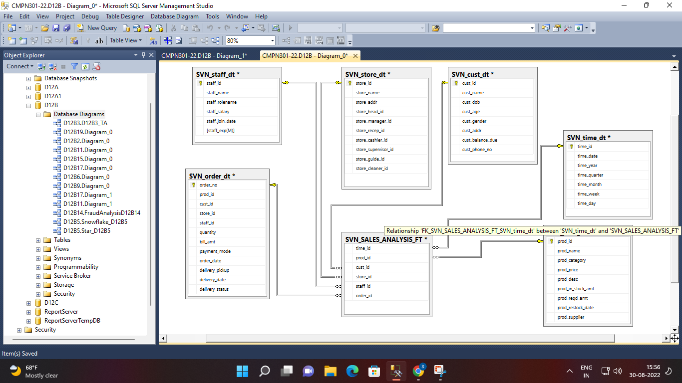

**Testing**

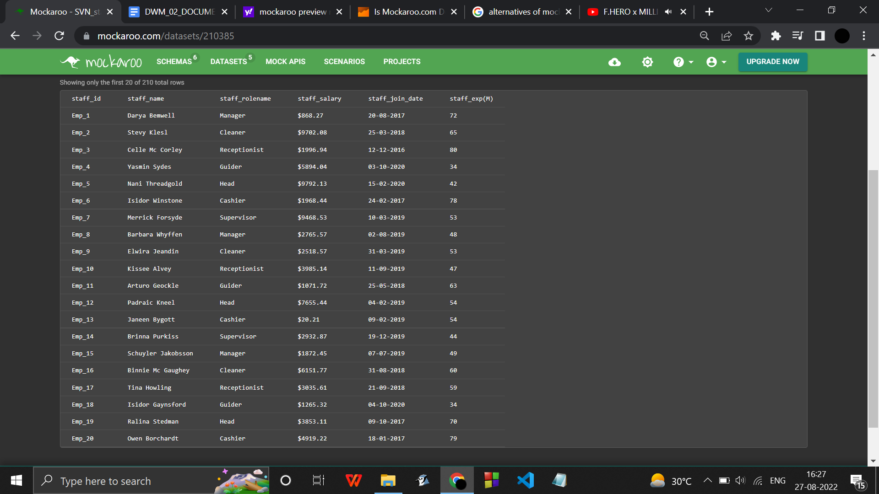

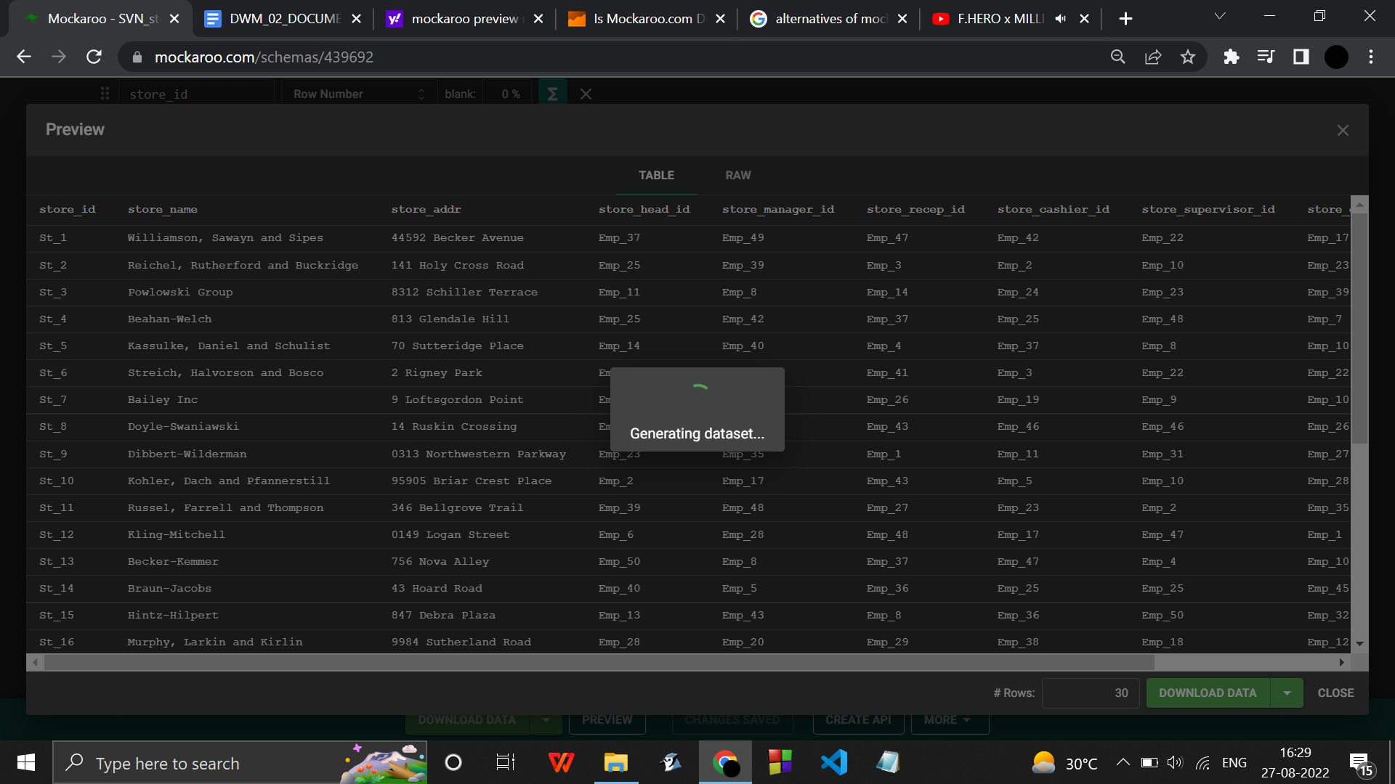

………………………………………………………………………………………

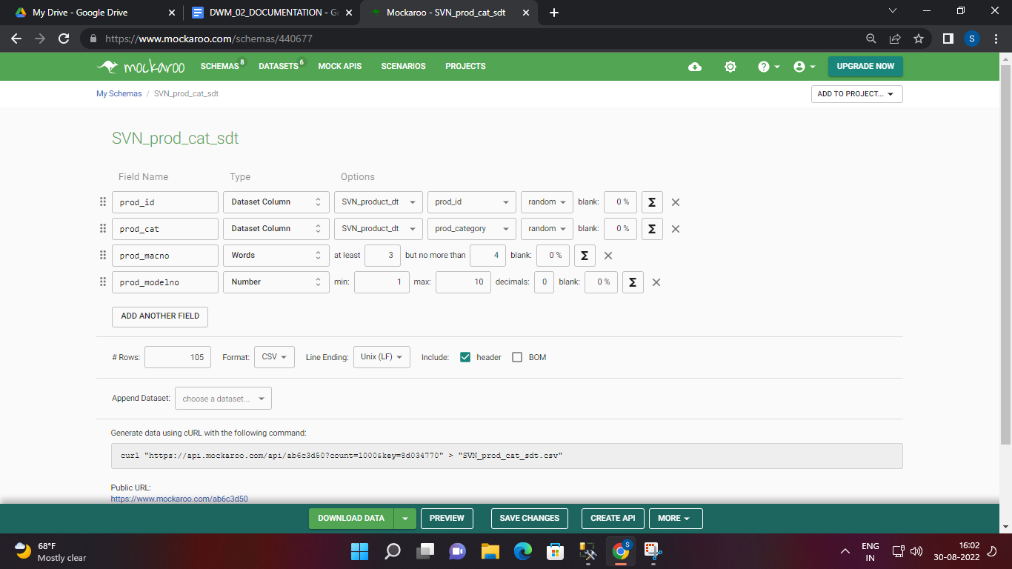

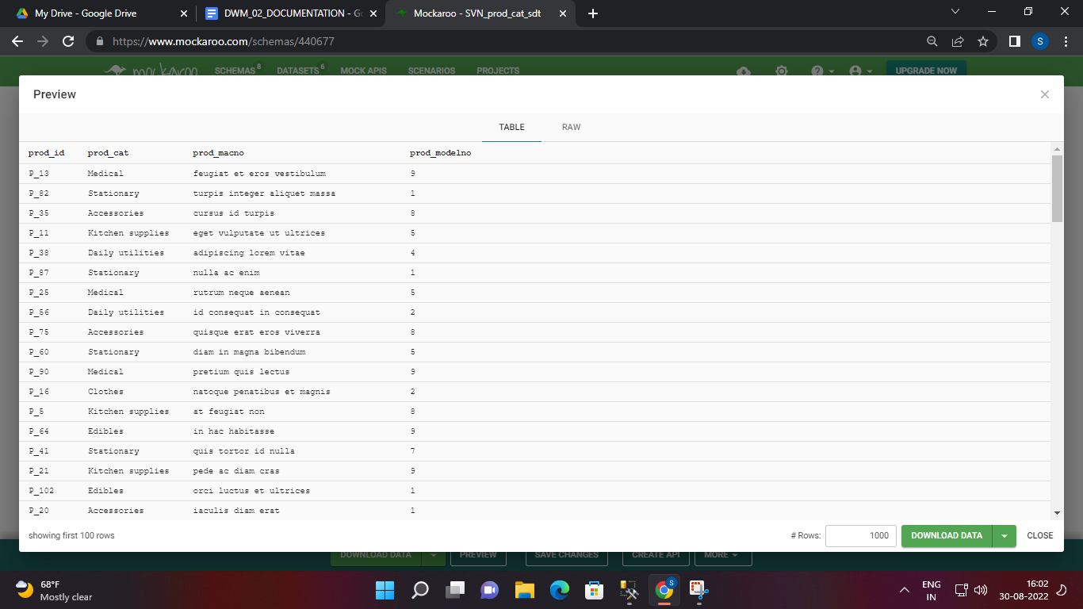

……………………………..

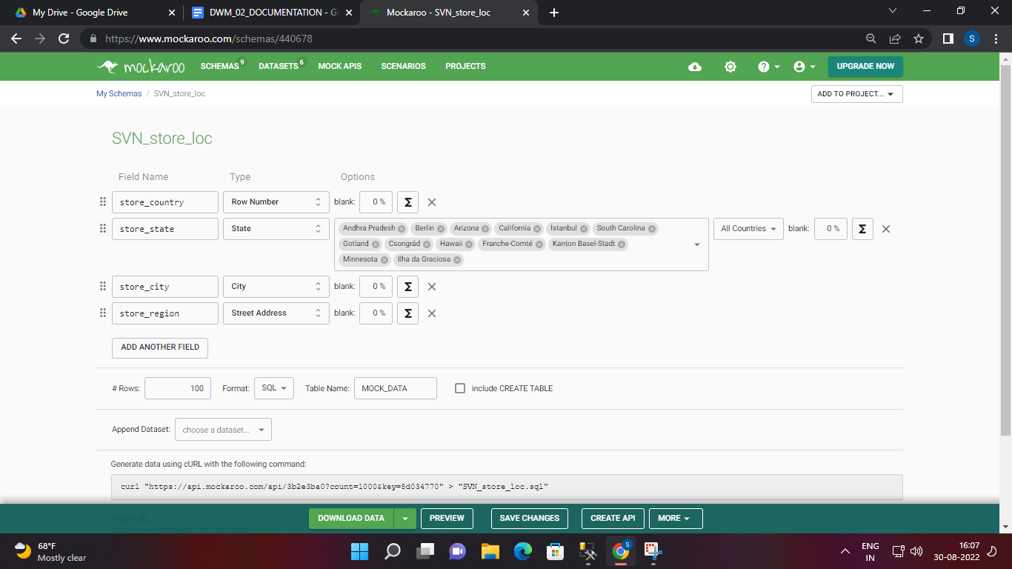

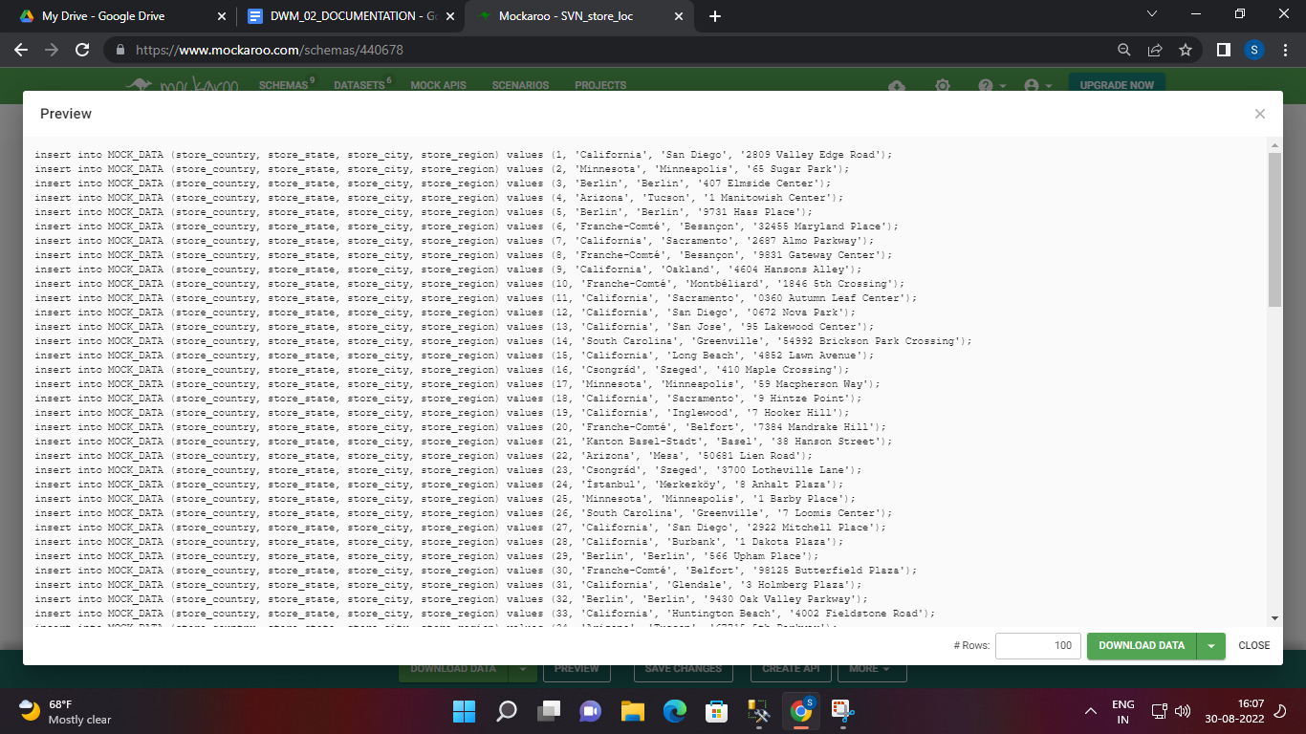

create table SVN_STORE_DT(

store_country INT,

store_state VARCHAR(50),

store_city VARCHAR(50),

store_region VARCHAR(50)

);

insert into SVN_STORE_DT(store_country, store_state, store_city, store_region) values (1, 'Arizona', 'Phoenix', '5 Jackson Street');

create table SVN_PROD_DT(

prod_id VARCHAR(50),

prod_cat VARCHAR(50),

prod_macno TEXT,

prod_modelno INT

);

insert into SVN_PROD_DT(prod_id, prod_cat, prod_macno, prod_modelno) values ('P_97', 'Kitchen supplies', 'diam vitae quam', 1);

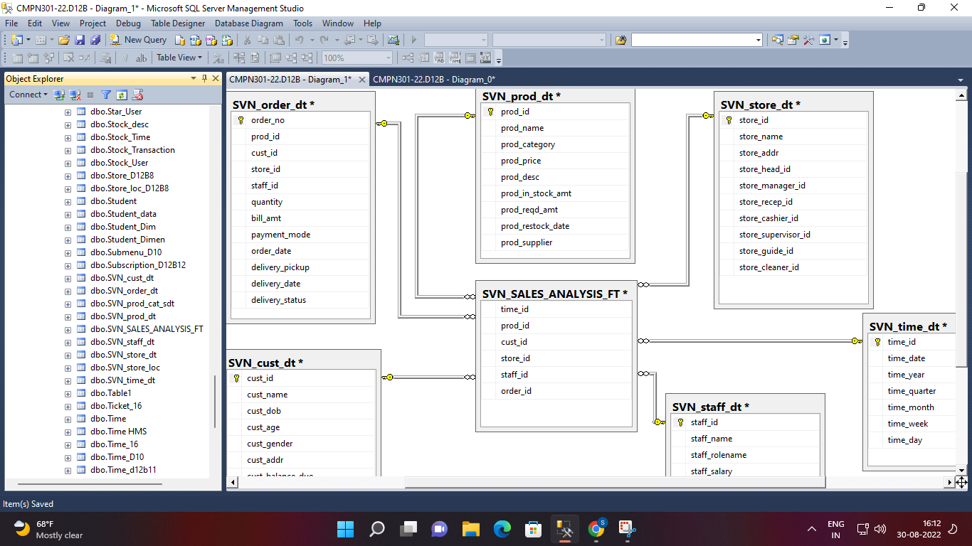

………………………………………………………………………………………STAR…………………………………………………………………………….

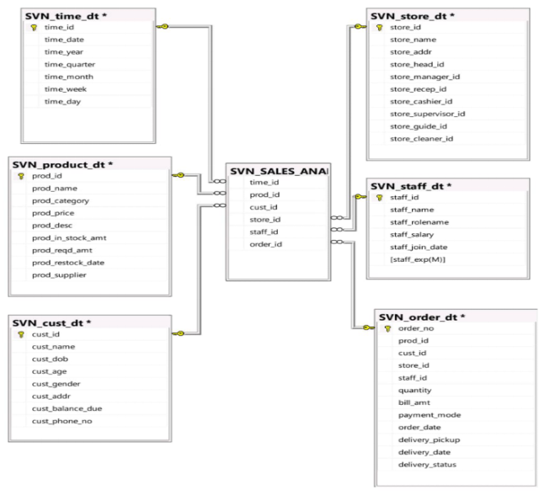

……………………………………………………………………………………..SNOWFLAKE…………………………………………………………………

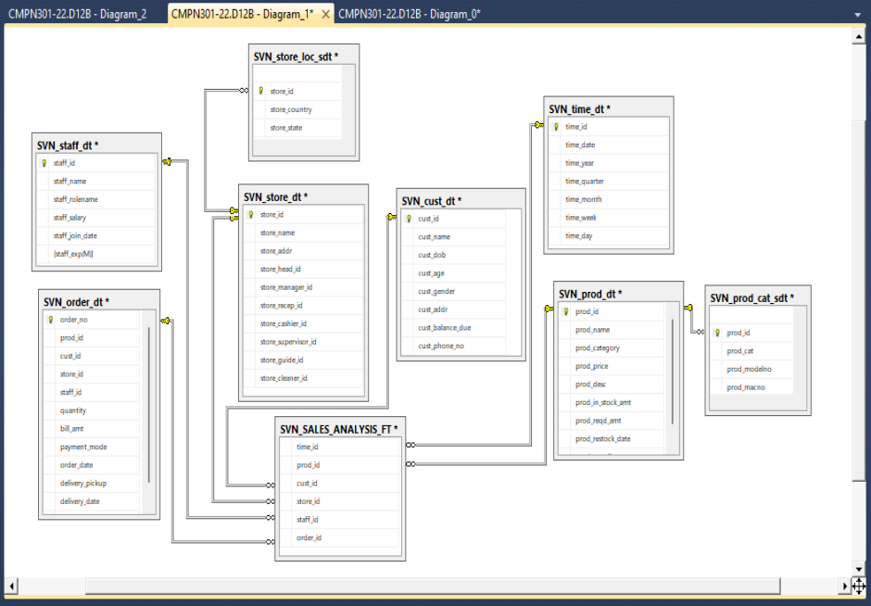

………………………………………………………………………………………………………………………………….

……………………………………………………………………………………………………………..

import random

list = []

def item_create():

list_item = [random.randint(1, 50), random.randint(1, 102), random.randint(1, 50), random.randint(1, 30),

random.randint(1, 210), random.randint(1, 1000)]

if list_item in list:

item_create()

return list_item

for i in range(1, 100):

list.append(item_create())

for i in list:

print(

f'insert into SVN_SALES_ANALYSIS_FT(time_id, prod_id, cust_id, store_id,staff_id,order_id,'

f' annual_sales,summer_sales,category_wise_sales ) values ({i[0]}, {i[1]}, {i[2]}, {i[3]}, {i[4]}, {i[5]}, '

f'{random.randint(1, 10000)}, {random.randint(1, 2000)}, {random.randint(1, 100)})')

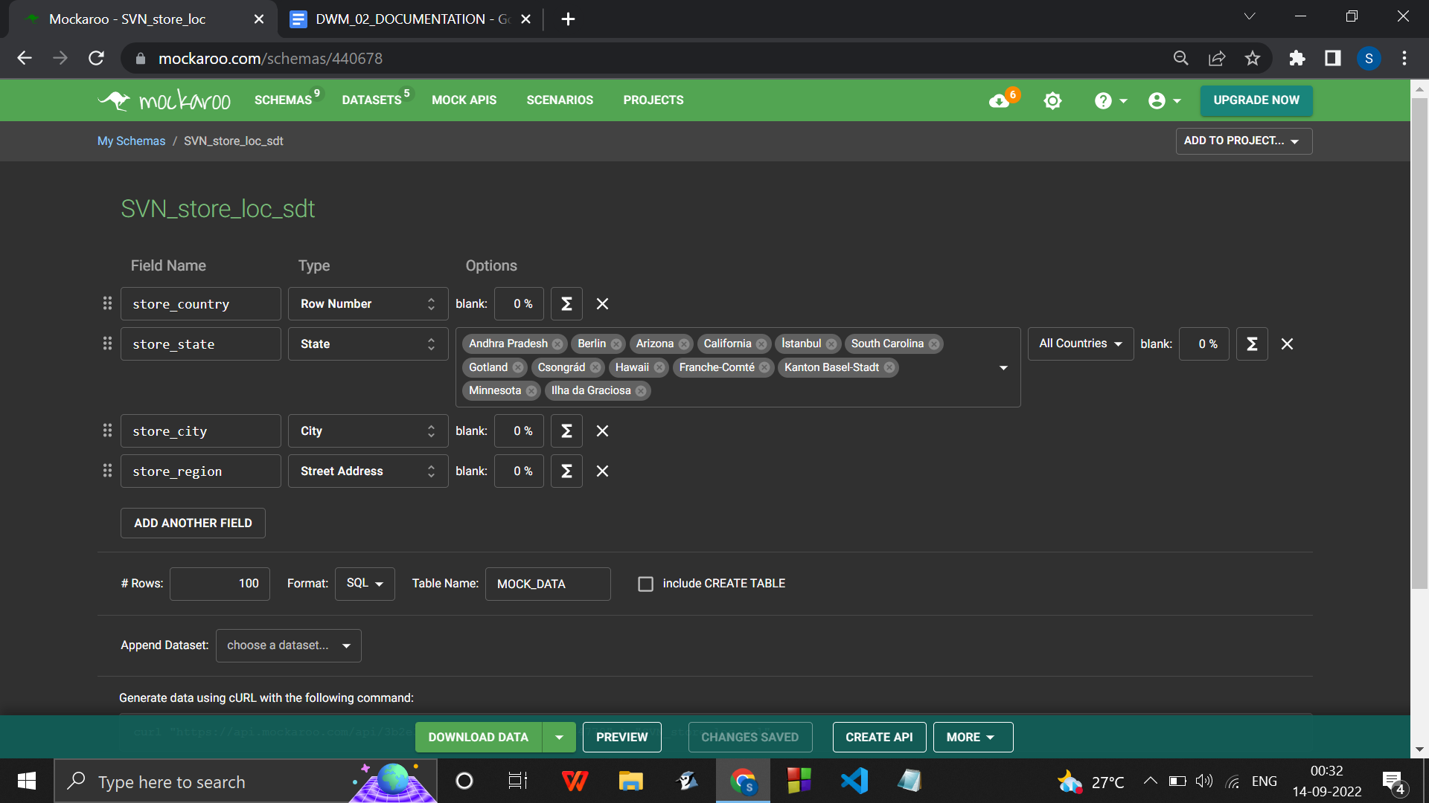

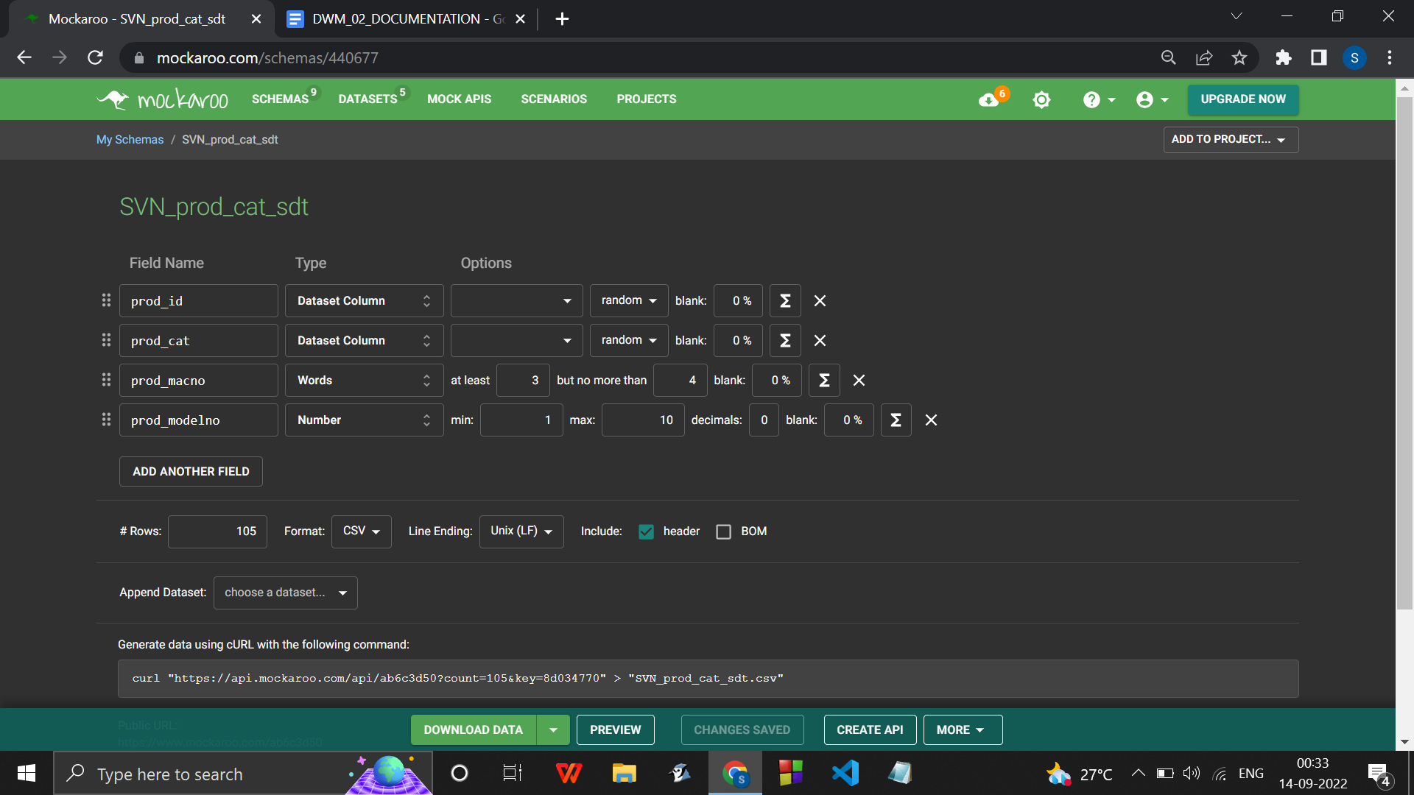

Fact table

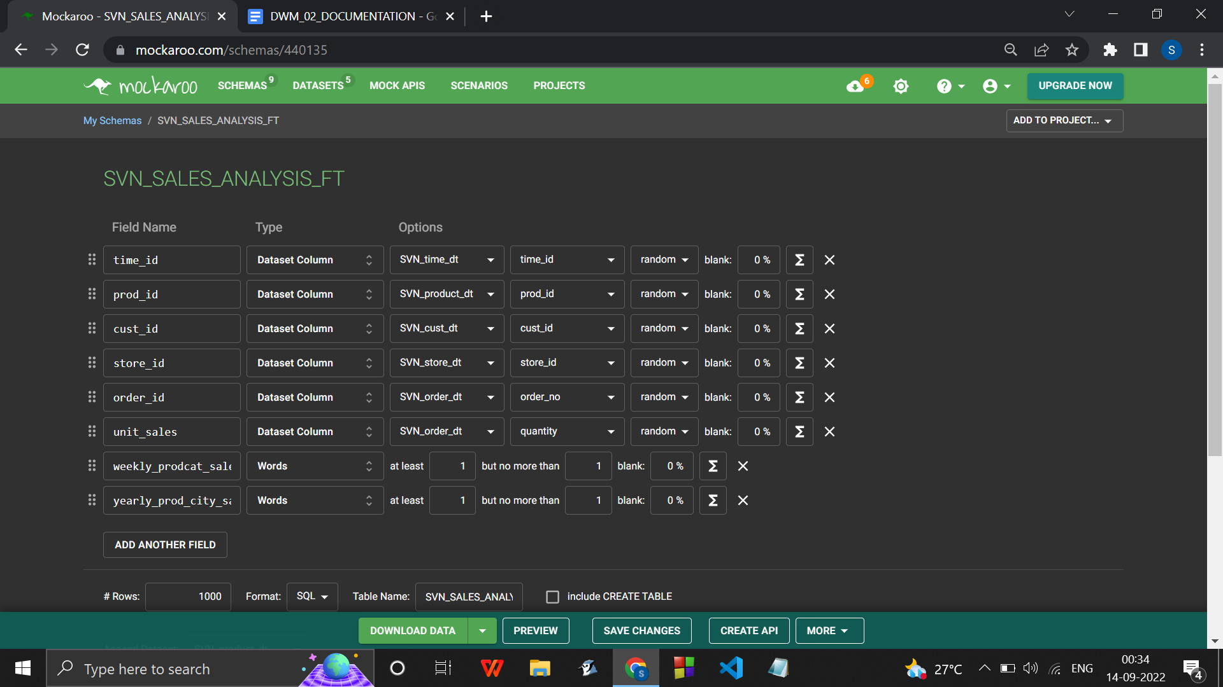

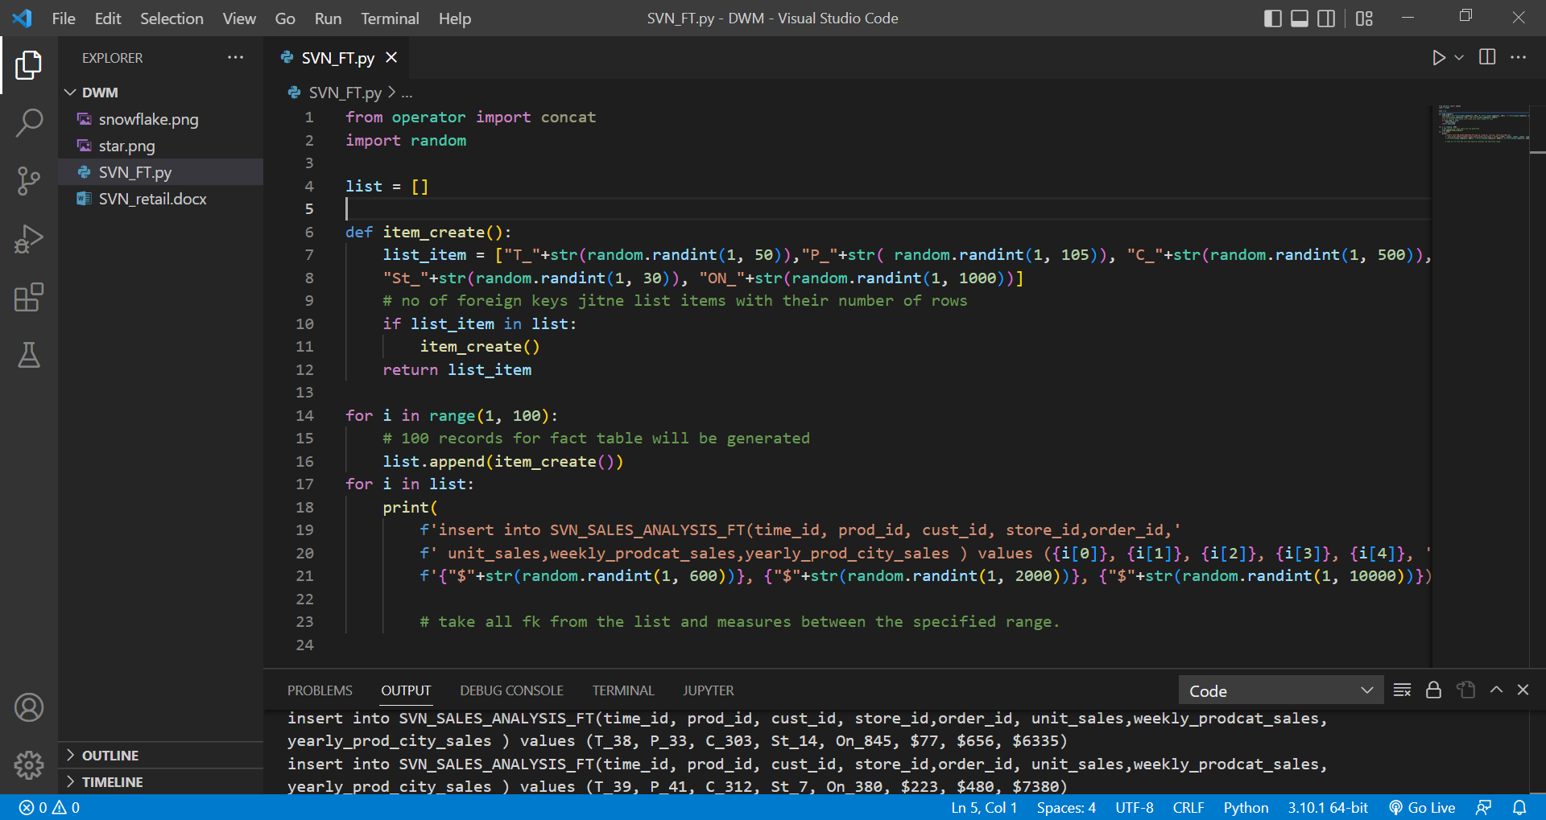

Code :

from operator import concat

import random

list = []

def item_create():

list_item = ["T_"+str(random.randint(1, 50)),"P_"+str( random.randint(1, 105)), "C_"+str(random.randint(1, 500)),

"St_"+str(random.randint(1, 30)), "ON_"+str(random.randint(1, 1000))]

# no of foreign keys jitne list items with their number of rows

if list_item in list:

item_create()

return list_item

for i in range(1, 100):

# 100 records for fact table will be generated

list.append(item_create())

for i in list:

print(

f'insert into SVN_SALES_ANALYSIS_FT(time_id, prod_id, cust_id, store_id,order_id,'

f' unit_sales,weekly_prodcat_sales,yearly_prod_city_sales ) values ({i[0]}, {i[1]}, {i[2]}, {i[3]}, {i[4]}, '

f'{"$"+str(random.randint(1, 600))}, {"$"+str(random.randint(1, 2000))}, {"$"+str(random.randint(1, 10000))})')

# take all fk from the list and measures between the specified range.

Output :

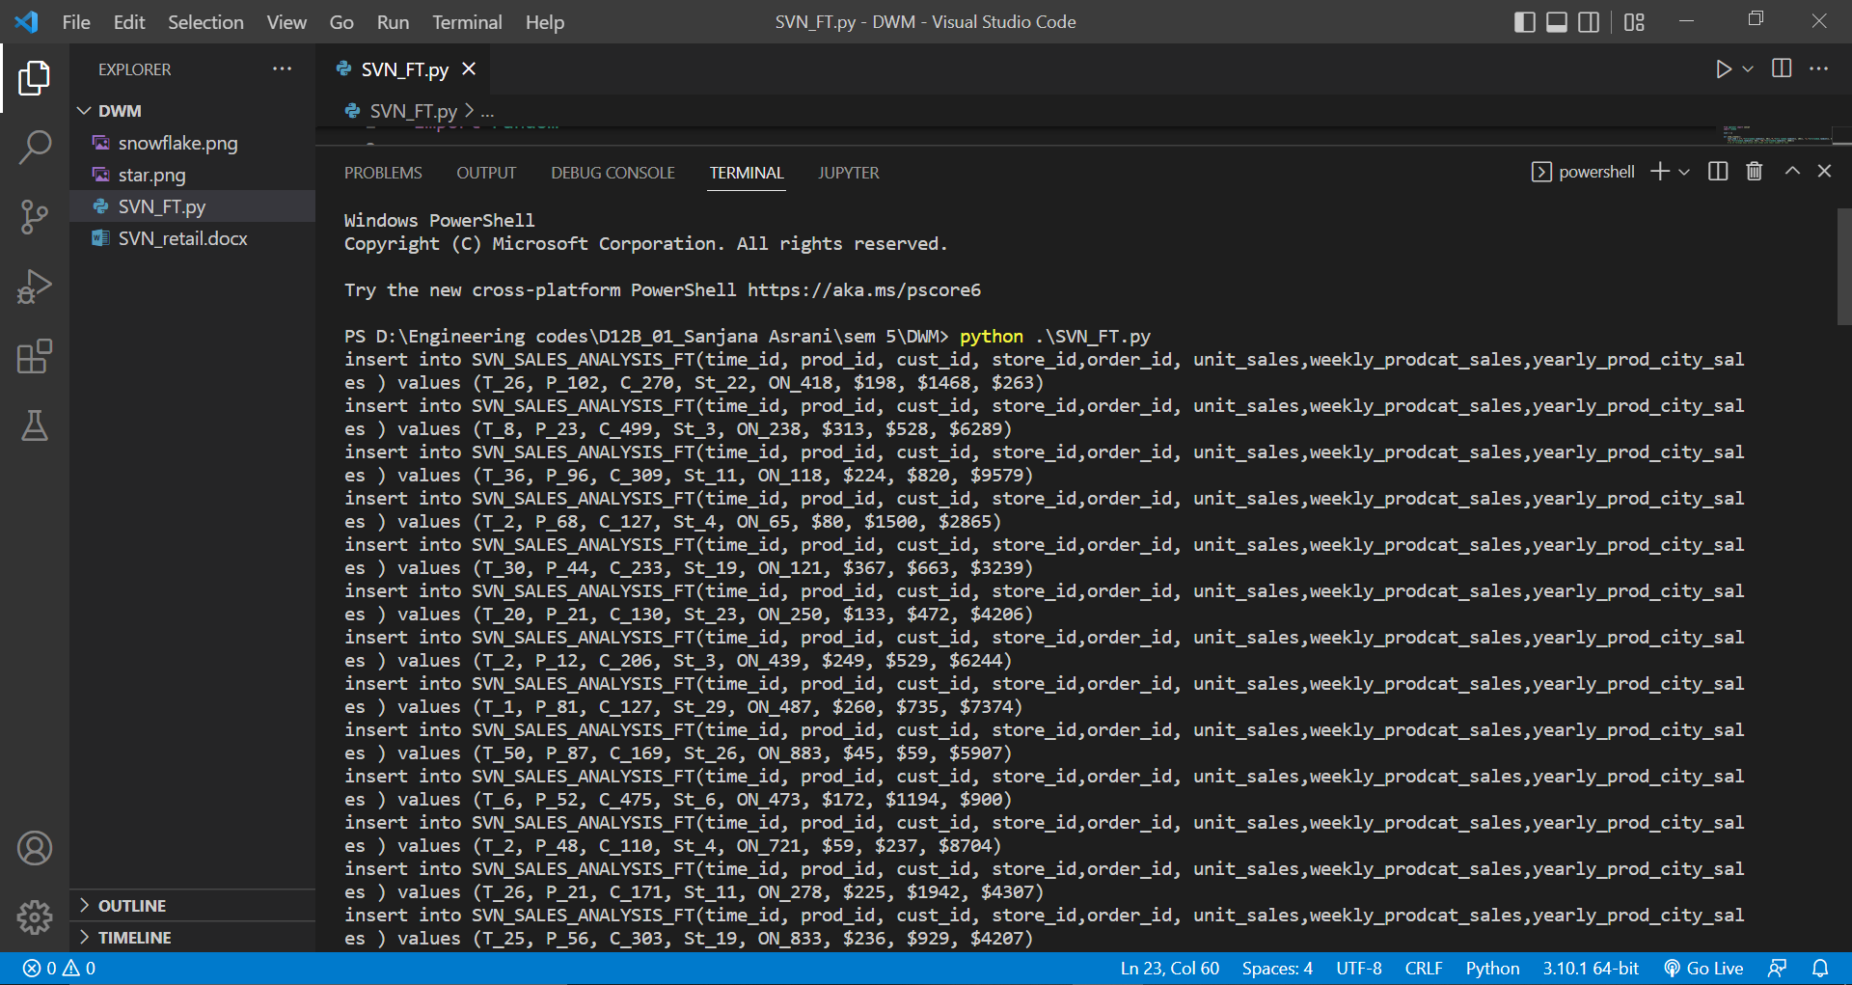

insert into SVN_SALES_ANALYSIS_FT(time_id, prod_id, cust_id, store_id,order_id, unit_sales,weekly_prodcat_sales,yearly_prod_city_sales ) values (T_26, P_102, C_270, St_22, ON_418, $198, $1468, $263)

insert into SVN_SALES_ANALYSIS_FT(time_id, prod_id, cust_id, store_id,order_id, unit_sales,weekly_prodcat_sales,yearly_prod_city_sales ) values (T_8, P_23, C_499, St_3, ON_238, $313, $528, $6289)

insert into SVN_SALES_ANALYSIS_FT(time_id, prod_id, cust_id, store_id,order_id, unit_sales,weekly_prodcat_sales,yearly_prod_city_sales ) values (T_36, P_96, C_309, St_11, ON_118, $224, $820, $9579)

insert into SVN_SALES_ANALYSIS_FT(time_id, prod_id, cust_id, store_id,order_id, unit_sales,weekly_prodcat_sales,yearly_prod_city_sales ) values (T_2, P_68, C_127, St_4, ON_65, $80, $1500, $2865)

insert into SVN_SALES_ANALYSIS_FT(time_id, prod_id, cust_id, store_id,order_id, unit_sales,weekly_prodcat_sales,yearly_prod_city_sales ) values (T_30, P_44, C_233, St_19, ON_121, $367, $663, $3239)

insert into SVN_SALES_ANALYSIS_FT(time_id, prod_id, cust_id, store_id,order_id, unit_sales,weekly_prodcat_sales,yearly_prod_city_sales ) values (T_20, P_21, C_130, St_23, ON_250, $133, $472, $4206)

insert into SVN_SALES_ANALYSIS_FT(time_id, prod_id, cust_id, store_id,order_id, unit_sales,weekly_prodcat_sales,yearly_prod_city_sales ) values (T_2, P_12, C_206, St_3, ON_439, $249, $529, $6244)

insert into SVN_SALES_ANALYSIS_FT(time_id, prod_id, cust_id, store_id,order_id, unit_sales,weekly_prodcat_sales,yearly_prod_city_sales ) values (T_1, P_81, C_127, St_29, ON_487, $260, $735, $7374)

insert into SVN_SALES_ANALYSIS_FT(time_id, prod_id, cust_id, store_id,order_id, unit_sales,weekly_prodcat_sales,yearly_prod_city_sales ) values (T_50, P_87, C_169, St_26, ON_883, $45, $59, $5907)

insert into SVN_SALES_ANALYSIS_FT(time_id, prod_id, cust_id, store_id,order_id, unit_sales,weekly_prodcat_sales,yearly_prod_city_sales ) values (T_6, P_52, C_475, St_6, ON_473, $172, $1194, $900)

insert into SVN_SALES_ANALYSIS_FT(time_id, prod_id, cust_id, store_id,order_id, unit_sales,weekly_prodcat_sales,yearly_prod_city_sales ) values (T_2, P_48, C_110, St_4, ON_721, $59, $237, $8704)

insert into SVN_SALES_ANALYSIS_FT(time_id, prod_id, cust_id, store_id,order_id, unit_sales,weekly_prodcat_sales,yearly_prod_city_sales ) values (T_26, P_21, C_171, St_11, ON_278, $225, $1942, $4307)

insert into SVN_SALES_ANALYSIS_FT(time_id, prod_id, cust_id, store_id,order_id, unit_sales,weekly_prodcat_sales,yearly_prod_city_sales ) values (T_25, P_56, C_303, St_19, ON_833, $236, $929, $4207)

insert into SVN_SALES_ANALYSIS_FT(time_id, prod_id, cust_id, store_id,order_id, unit_sales,weekly_prodcat_sales,yearly_prod_city_sales ) values (T_20, P_19, C_170, St_22, ON_569, $424, $1430, $2890)

insert into SVN_SALES_ANALYSIS_FT(time_id, prod_id, cust_id, store_id,order_id, unit_sales,weekly_prodcat_sales,yearly_prod_city_sales ) values (T_17, P_70, C_340, St_15, ON_173, $157, $1346, $8446)

insert into SVN_SALES_ANALYSIS_FT(time_id, prod_id, cust_id, store_id,order_id, unit_sales,weekly_prodcat_sales,yearly_prod_city_sales ) values (T_41, P_51, C_199, St_3, ON_136, $396, $529, $5129)

insert into SVN_SALES_ANALYSIS_FT(time_id, prod_id, cust_id, store_id,order_id, unit_sales,weekly_prodcat_sales,yearly_prod_city_sales ) values (T_34, P_71, C_192, St_19, ON_879, $549, $703, $1737)

insert into SVN_SALES_ANALYSIS_FT(time_id, prod_id, cust_id, store_id,order_id, unit_sales,weekly_prodcat_sales,yearly_prod_city_sales ) values (T_36, P_74, C_171, St_15, ON_746, $239, $555, $8645)

insert into SVN_SALES_ANALYSIS_FT(time_id, prod_id, cust_id, store_id,order_id, unit_sales,weekly_prodcat_sales,yearly_prod_city_sales ) values (T_17, P_70, C_463, St_20, ON_710, $329, $372, $866)

insert into SVN_SALES_ANALYSIS_FT(time_id, prod_id, cust_id, store_id,order_id, unit_sales,weekly_prodcat_sales,yearly_prod_city_sales ) values (T_47, P_58, C_78, St_30, ON_202, $207, $497, $5738)

insert into SVN_SALES_ANALYSIS_FT(time_id, prod_id, cust_id, store_id,order_id, unit_sales,weekly_prodcat_sales,yearly_prod_city_sales ) values (T_41, P_45, C_15, St_5, ON_172, $169, $329, $5974)

insert into SVN_SALES_ANALYSIS_FT(time_id, prod_id, cust_id, store_id,order_id, unit_sales,weekly_prodcat_sales,yearly_prod_city_sales ) values (T_37, P_75, C_336, St_9, ON_760, $270, $1322, $4451)

insert into SVN_SALES_ANALYSIS_FT(time_id, prod_id, cust_id, store_id,order_id, unit_sales,weekly_prodcat_sales,yearly_prod_city_sales ) values (T_42, P_102, C_343, St_25, ON_132, $286, $204, $7497)

insert into SVN_SALES_ANALYSIS_FT(time_id, prod_id, cust_id, store_id,order_id, unit_sales,weekly_prodcat_sales,yearly_prod_city_sales ) values (T_40, P_56, C_16, St_19, ON_657, $330, $1514, $9680)

insert into SVN_SALES_ANALYSIS_FT(time_id, prod_id, cust_id, store_id,order_id, unit_sales,weekly_prodcat_sales,yearly_prod_city_sales ) values (T_11, P_62, C_462, St_25, ON_193, $65, $632, $4617)

insert into SVN_SALES_ANALYSIS_FT(time_id, prod_id, cust_id, store_id,order_id, unit_sales,weekly_prodcat_sales,yearly_prod_city_sales ) values (T_27, P_17, C_94, St_11, ON_312, $377, $799, $6412)

insert into SVN_SALES_ANALYSIS_FT(time_id, prod_id, cust_id, store_id,order_id, unit_sales,weekly_prodcat_sales,yearly_prod_city_sales ) values (T_46, P_32, C_175, St_22, ON_898, $518, $18, $6333)

insert into SVN_SALES_ANALYSIS_FT(time_id, prod_id, cust_id, store_id,order_id, unit_sales,weekly_prodcat_sales,yearly_prod_city_sales ) values (T_32, P_68, C_367, St_7, ON_407, $199, $1399, $5626)

insert into SVN_SALES_ANALYSIS_FT(time_id, prod_id, cust_id, store_id,order_id, unit_sales,weekly_prodcat_sales,yearly_prod_city_sales ) values (T_42, P_75, C_279, St_8, ON_30, $516, $1641, $7542)

insert into SVN_SALES_ANALYSIS_FT(time_id, prod_id, cust_id, store_id,order_id, unit_sales,weekly_prodcat_sales,yearly_prod_city_sales ) values (T_8, P_79, C_371, St_13, ON_496, $427, $1637, $8370)

insert into SVN_SALES_ANALYSIS_FT(time_id, prod_id, cust_id, store_id,order_id, unit_sales,weekly_prodcat_sales,yearly_prod_city_sales ) values (T_50, P_87, C_202, St_25, ON_573, $471, $814, $8966)

insert into SVN_SALES_ANALYSIS_FT(time_id, prod_id, cust_id, store_id,order_id, unit_sales,weekly_prodcat_sales,yearly_prod_city_sales ) values (T_36, P_48, C_372, St_27, ON_937, $178, $333, $2978)

insert into SVN_SALES_ANALYSIS_FT(time_id, prod_id, cust_id, store_id,order_id, unit_sales,weekly_prodcat_sales,yearly_prod_city_sales ) values (T_48, P_19, C_216, St_21, ON_682, $93, $476, $4622)

insert into SVN_SALES_ANALYSIS_FT(time_id, prod_id, cust_id, store_id,order_id, unit_sales,weekly_prodcat_sales,yearly_prod_city_sales ) values (T_16, P_85, C_373, St_28, ON_39, $180, $313, $8392)

insert into SVN_SALES_ANALYSIS_FT(time_id, prod_id, cust_id, store_id,order_id, unit_sales,weekly_prodcat_sales,yearly_prod_city_sales ) values (T_21, P_37, C_294, St_20, ON_456, $386, $218, $6322)

insert into SVN_SALES_ANALYSIS_FT(time_id, prod_id, cust_id, store_id,order_id, unit_sales,weekly_prodcat_sales,yearly_prod_city_sales ) values (T_26, P_86, C_456, St_11, ON_301, $103, $1799, $1693)

insert into SVN_SALES_ANALYSIS_FT(time_id, prod_id, cust_id, store_id,order_id, unit_sales,weekly_prodcat_sales,yearly_prod_city_sales ) values (T_26, P_87, C_460, St_3, ON_493, $84, $1935, $876)

insert into SVN_SALES_ANALYSIS_FT(time_id, prod_id, cust_id, store_id,order_id, unit_sales,weekly_prodcat_sales,yearly_prod_city_sales ) values (T_44, P_104, C_130, St_7, ON_502, $203, $553, $8837)

insert into SVN_SALES_ANALYSIS_FT(time_id, prod_id, cust_id, store_id,order_id, unit_sales,weekly_prodcat_sales,yearly_prod_city_sales ) values (T_13, P_104, C_334, St_15, ON_302, $199, $318, $3246)

insert into SVN_SALES_ANALYSIS_FT(time_id, prod_id, cust_id, store_id,order_id, unit_sales,weekly_prodcat_sales,yearly_prod_city_sales ) values (T_18, P_86, C_289, St_15, ON_664, $464, $1264, $2365)

insert into SVN_SALES_ANALYSIS_FT(time_id, prod_id, cust_id, store_id,order_id, unit_sales,weekly_prodcat_sales,yearly_prod_city_sales ) values (T_35, P_6, C_315, St_21, ON_912, $55, $1455, $9154)

insert into SVN_SALES_ANALYSIS_FT(time_id, prod_id, cust_id, store_id,order_id, unit_sales,weekly_prodcat_sales,yearly_prod_city_sales ) values (T_35, P_16, C_345, St_12, ON_884, $223, $1891, $5610)

insert into SVN_SALES_ANALYSIS_FT(time_id, prod_id, cust_id, store_id,order_id, unit_sales,weekly_prodcat_sales,yearly_prod_city_sales ) values (T_26, P_37, C_338, St_19, ON_977, $568, $1686, $5126)

insert into SVN_SALES_ANALYSIS_FT(time_id, prod_id, cust_id, store_id,order_id, unit_sales,weekly_prodcat_sales,yearly_prod_city_sales ) values (T_38, P_75, C_46, St_24, ON_62, $44, $1335, $4169)

insert into SVN_SALES_ANALYSIS_FT(time_id, prod_id, cust_id, store_id,order_id, unit_sales,weekly_prodcat_sales,yearly_prod_city_sales ) values (T_22, P_94, C_55, St_13, ON_621, $55, $1881, $3090)

insert into SVN_SALES_ANALYSIS_FT(time_id, prod_id, cust_id, store_id,order_id, unit_sales,weekly_prodcat_sales,yearly_prod_city_sales ) values (T_34, P_58, C_226, St_23, ON_203, $310, $71, $3411)

insert into SVN_SALES_ANALYSIS_FT(time_id, prod_id, cust_id, store_id,order_id, unit_sales,weekly_prodcat_sales,yearly_prod_city_sales ) values (T_25, P_75, C_241, St_27, ON_285, $398, $1043, $9651)

insert into SVN_SALES_ANALYSIS_FT(time_id, prod_id, cust_id, store_id,order_id, unit_sales,weekly_prodcat_sales,yearly_prod_city_sales ) values (T_33, P_50, C_407, St_18, ON_454, $181, $435, $4741)

insert into SVN_SALES_ANALYSIS_FT(time_id, prod_id, cust_id, store_id,order_id, unit_sales,weekly_prodcat_sales,yearly_prod_city_sales ) values (T_20, P_50, C_232, St_7, ON_24, $139, $1938, $5854)

insert into SVN_SALES_ANALYSIS_FT(time_id, prod_id, cust_id, store_id,order_id, unit_sales,weekly_prodcat_sales,yearly_prod_city_sales ) values (T_31, P_84, C_478, St_5, ON_38, $28, $1750, $8078)

insert into SVN_SALES_ANALYSIS_FT(time_id, prod_id, cust_id, store_id,order_id, unit_sales,weekly_prodcat_sales,yearly_prod_city_sales ) values (T_13, P_66, C_469, St_14, ON_813, $121, $1778, $9297)

insert into SVN_SALES_ANALYSIS_FT(time_id, prod_id, cust_id, store_id,order_id, unit_sales,weekly_prodcat_sales,yearly_prod_city_sales ) values (T_40, P_83, C_497, St_28, ON_929, $430, $221, $7652)

insert into SVN_SALES_ANALYSIS_FT(time_id, prod_id, cust_id, store_id,order_id, unit_sales,weekly_prodcat_sales,yearly_prod_city_sales ) values (T_32, P_40, C_15, St_1, ON_18, $211, $1540, $7795)

insert into SVN_SALES_ANALYSIS_FT(time_id, prod_id, cust_id, store_id,order_id, unit_sales,weekly_prodcat_sales,yearly_prod_city_sales ) values (T_46, P_22, C_478, St_19, ON_748, $64, $1521, $9390)

insert into SVN_SALES_ANALYSIS_FT(time_id, prod_id, cust_id, store_id,order_id, unit_sales,weekly_prodcat_sales,yearly_prod_city_sales ) values (T_47, P_101, C_19, St_20, ON_720, $38, $299, $6515)

insert into SVN_SALES_ANALYSIS_FT(time_id, prod_id, cust_id, store_id,order_id, unit_sales,weekly_prodcat_sales,yearly_prod_city_sales ) values (T_4, P_8, C_457, St_18, ON_263, $182, $1874, $5672)

insert into SVN_SALES_ANALYSIS_FT(time_id, prod_id, cust_id, store_id,order_id, unit_sales,weekly_prodcat_sales,yearly_prod_city_sales ) values (T_22, P_100, C_315, St_30, ON_491, $480, $1530, $7809)

insert into SVN_SALES_ANALYSIS_FT(time_id, prod_id, cust_id, store_id,order_id, unit_sales,weekly_prodcat_sales,yearly_prod_city_sales ) values (T_10, P_35, C_155, St_25, ON_861, $507, $1241, $9418)

insert into SVN_SALES_ANALYSIS_FT(time_id, prod_id, cust_id, store_id,order_id, unit_sales,weekly_prodcat_sales,yearly_prod_city_sales ) values (T_27, P_4, C_212, St_18, ON_185, $243, $1161, $4985)

insert into SVN_SALES_ANALYSIS_FT(time_id, prod_id, cust_id, store_id,order_id, unit_sales,weekly_prodcat_sales,yearly_prod_city_sales ) values (T_20, P_14, C_126, St_14, ON_816, $69, $1198, $1956)

insert into SVN_SALES_ANALYSIS_FT(time_id, prod_id, cust_id, store_id,order_id, unit_sales,weekly_prodcat_sales,yearly_prod_city_sales ) values (T_10, P_21, C_187, St_12, ON_649, $386, $42, $4958)

insert into SVN_SALES_ANALYSIS_FT(time_id, prod_id, cust_id, store_id,order_id, unit_sales,weekly_prodcat_sales,yearly_prod_city_sales ) values (T_15, P_61, C_202, St_29, ON_906, $56, $1388, $719)

insert into SVN_SALES_ANALYSIS_FT(time_id, prod_id, cust_id, store_id,order_id, unit_sales,weekly_prodcat_sales,yearly_prod_city_sales ) values (T_3, P_20, C_57, St_8, ON_505, $531, $594, $4920)

insert into SVN_SALES_ANALYSIS_FT(time_id, prod_id, cust_id, store_id,order_id, unit_sales,weekly_prodcat_sales,yearly_prod_city_sales ) values (T_18, P_24, C_213, St_26, ON_171, $562, $612, $601)

insert into SVN_SALES_ANALYSIS_FT(time_id, prod_id, cust_id, store_id,order_id, unit_sales,weekly_prodcat_sales,yearly_prod_city_sales ) values (T_19, P_84, C_140, St_29, ON_201, $597, $1675, $8105)

insert into SVN_SALES_ANALYSIS_FT(time_id, prod_id, cust_id, store_id,order_id, unit_sales,weekly_prodcat_sales,yearly_prod_city_sales ) values (T_18, P_19, C_366, St_29, ON_19, $237, $366, $8890)

insert into SVN_SALES_ANALYSIS_FT(time_id, prod_id, cust_id, store_id,order_id, unit_sales,weekly_prodcat_sales,yearly_prod_city_sales ) values (T_7, P_66, C_161, St_8, ON_699, $340, $1738, $6152)

insert into SVN_SALES_ANALYSIS_FT(time_id, prod_id, cust_id, store_id,order_id, unit_sales,weekly_prodcat_sales,yearly_prod_city_sales ) values (T_48, P_59, C_458, St_21, ON_925, $45, $542, $8738)

insert into SVN_SALES_ANALYSIS_FT(time_id, prod_id, cust_id, store_id,order_id, unit_sales,weekly_prodcat_sales,yearly_prod_city_sales ) values (T_24, P_15, C_139, St_16, ON_718, $597, $980, $517)

insert into SVN_SALES_ANALYSIS_FT(time_id, prod_id, cust_id, store_id,order_id, unit_sales,weekly_prodcat_sales,yearly_prod_city_sales ) values (T_49, P_15, C_14, St_21, ON_276, $473, $1975, $7659)

insert into SVN_SALES_ANALYSIS_FT(time_id, prod_id, cust_id, store_id,order_id, unit_sales,weekly_prodcat_sales,yearly_prod_city_sales ) values (T_43, P_91, C_459, St_29, ON_540, $367, $560, $4699)

insert into SVN_SALES_ANALYSIS_FT(time_id, prod_id, cust_id, store_id,order_id, unit_sales,weekly_prodcat_sales,yearly_prod_city_sales ) values (T_29, P_104, C_288, St_16, ON_528, $296, $447, $3831)

insert into SVN_SALES_ANALYSIS_FT(time_id, prod_id, cust_id, store_id,order_id, unit_sales,weekly_prodcat_sales,yearly_prod_city_sales ) values (T_22, P_21, C_131, St_1, ON_281, $70, $467, $3431)

insert into SVN_SALES_ANALYSIS_FT(time_id, prod_id, cust_id, store_id,order_id, unit_sales,weekly_prodcat_sales,yearly_prod_city_sales ) values (T_15, P_93, C_21, St_14, ON_11, $327, $412, $8961)

insert into SVN_SALES_ANALYSIS_FT(time_id, prod_id, cust_id, store_id,order_id, unit_sales,weekly_prodcat_sales,yearly_prod_city_sales ) values (T_32, P_1, C_349, St_28, ON_432, $150, $598, $7178)

insert into SVN_SALES_ANALYSIS_FT(time_id, prod_id, cust_id, store_id,order_id, unit_sales,weekly_prodcat_sales,yearly_prod_city_sales ) values (T_8, P_92, C_443, St_11, ON_953, $188, $357, $8695)

insert into SVN_SALES_ANALYSIS_FT(time_id, prod_id, cust_id, store_id,order_id, unit_sales,weekly_prodcat_sales,yearly_prod_city_sales ) values (T_15, P_22, C_104, St_4, ON_383, $47, $162, $4169)

insert into SVN_SALES_ANALYSIS_FT(time_id, prod_id, cust_id, store_id,order_id, unit_sales,weekly_prodcat_sales,yearly_prod_city_sales ) values (T_49, P_79, C_82, St_28, ON_762, $128, $1769, $2099)

insert into SVN_SALES_ANALYSIS_FT(time_id, prod_id, cust_id, store_id,order_id, unit_sales,weekly_prodcat_sales,yearly_prod_city_sales ) values (T_33, P_79, C_277, St_20, ON_532, $427, $103, $1997)

insert into SVN_SALES_ANALYSIS_FT(time_id, prod_id, cust_id, store_id,order_id, unit_sales,weekly_prodcat_sales,yearly_prod_city_sales ) values (T_40, P_95, C_303, St_15, ON_891, $118, $221, $3862)

insert into SVN_SALES_ANALYSIS_FT(time_id, prod_id, cust_id, store_id,order_id, unit_sales,weekly_prodcat_sales,yearly_prod_city_sales ) values (T_23, P_77, C_450, St_25, ON_880, $229, $1259, $8006)

insert into SVN_SALES_ANALYSIS_FT(time_id, prod_id, cust_id, store_id,order_id, unit_sales,weekly_prodcat_sales,yearly_prod_city_sales ) values (T_3, P_55, C_457, St_14, ON_936, $559, $412, $7507)

insert into SVN_SALES_ANALYSIS_FT(time_id, prod_id, cust_id, store_id,order_id, unit_sales,weekly_prodcat_sales,yearly_prod_city_sales ) values (T_19, P_32, C_466, St_26, ON_890, $365, $1236, $4274)

insert into SVN_SALES_ANALYSIS_FT(time_id, prod_id, cust_id, store_id,order_id, unit_sales,weekly_prodcat_sales,yearly_prod_city_sales ) values (T_5, P_43, C_306, St_9, ON_198, $400, $1351, $9062)

insert into SVN_SALES_ANALYSIS_FT(time_id, prod_id, cust_id, store_id,order_id, unit_sales,weekly_prodcat_sales,yearly_prod_city_sales ) values (T_16, P_2, C_78, St_24, ON_361, $537, $371, $9287)

insert into SVN_SALES_ANALYSIS_FT(time_id, prod_id, cust_id, store_id,order_id, unit_sales,weekly_prodcat_sales,yearly_prod_city_sales ) values (T_42, P_35, C_26, St_7, ON_430, $258, $1835, $5913)

insert into SVN_SALES_ANALYSIS_FT(time_id, prod_id, cust_id, store_id,order_id, unit_sales,weekly_prodcat_sales,yearly_prod_city_sales ) values (T_44, P_93, C_29, St_2, ON_132, $133, $1744, $310)

insert into SVN_SALES_ANALYSIS_FT(time_id, prod_id, cust_id, store_id,order_id, unit_sales,weekly_prodcat_sales,yearly_prod_city_sales ) values (T_26, P_52, C_356, St_5, ON_646, $222, $1264, $5011)

insert into SVN_SALES_ANALYSIS_FT(time_id, prod_id, cust_id, store_id,order_id, unit_sales,weekly_prodcat_sales,yearly_prod_city_sales ) values (T_45, P_29, C_332, St_23, ON_252, $554, $1060, $5024)

insert into SVN_SALES_ANALYSIS_FT(time_id, prod_id, cust_id, store_id,order_id, unit_sales,weekly_prodcat_sales,yearly_prod_city_sales ) values (T_8, P_33, C_328, St_20, ON_72, $233, $916, $8849)

insert into SVN_SALES_ANALYSIS_FT(time_id, prod_id, cust_id, store_id,order_id, unit_sales,weekly_prodcat_sales,yearly_prod_city_sales ) values (T_25, P_70, C_321, St_19, ON_490, $17, $1295, $6446)

insert into SVN_SALES_ANALYSIS_FT(time_id, prod_id, cust_id, store_id,order_id, unit_sales,weekly_prodcat_sales,yearly_prod_city_sales ) values (T_35, P_40, C_91, St_23, ON_247, $9, $1631, $3575)

insert into SVN_SALES_ANALYSIS_FT(time_id, prod_id, cust_id, store_id,order_id, unit_sales,weekly_prodcat_sales,yearly_prod_city_sales ) values (T_13, P_53, C_330, St_16, ON_735, $50, $1117, $5580)

insert into SVN_SALES_ANALYSIS_FT(time_id, prod_id, cust_id, store_id,order_id, unit_sales,weekly_prodcat_sales,yearly_prod_city_sales ) values (T_17, P_94, C_269, St_29, ON_329, $510, $1061, $4060)

insert into SVN_SALES_ANALYSIS_FT(time_id, prod_id, cust_id, store_id,order_id, unit_sales,weekly_prodcat_sales,yearly_prod_city_sales ) values (T_47, P_97, C_411, St_12, ON_196, $25, $630, $2436)

insert into SVN_SALES_ANALYSIS_FT(time_id, prod_id, cust_id, store_id,order_id, unit_sales,weekly_prodcat_sales,yearly_prod_city_sales ) values (T_37, P_61, C_372, St_15, ON_45, $194, $1606, $4019)

insert into SVN_SALES_ANALYSIS_FT(time_id, prod_id, cust_id, store_id,order_id, unit_sales,weekly_prodcat_sales,yearly_prod_city_sales ) values (T_15, P_64, C_316, St_20, ON_555, $319, $204, $5149)

insert into SVN_SALES_ANALYSIS_FT(time_id, prod_id, cust_id, store_id,order_id, unit_sales,weekly_prodcat_sales,yearly_prod_city_sales ) values (T_8, P_31, C_498, St_7, ON_714, $554, $321, $1766)

insert into SVN_SALES_ANALYSIS_FT(time_id, prod_id, cust_id, store_id,order_id, unit_sales,weekly_prodcat_sales,yearly_prod_city_sales ) values (T_28, P_62, C_191, St_28, ON_13, $319, $248, $8367)

QUERIES TO BE PERFORMED :

1. FIND UNIT SALES OF EACH PRODUCT 1 way aggregate
2. FIND WEEKLY PROD CAT WISE SALES2 way aggregate

Select SVN_TIME_DT.time_week, SVN_PROD_DT.PROD_CAT

1. FIND YEARLY PROD WISE CITY WISE SALES3 way aggregate

QUERIES TO BE PERFORMED :

Group by prod cat , count how many prod in each cat and their unit sales=order.quantity*prod.prod_price

OLAP OPN QUERIES :

PROD , TIME , LOCN

Select * from order

1. Roll up
2. DRILL UP

3.SLICE

4. DICE

5. PIVOT

SELECT COUNT(prod_id), prod_id

FROM SVN_SALES_ANALYSIS_FT

GROUP BY prod_id;

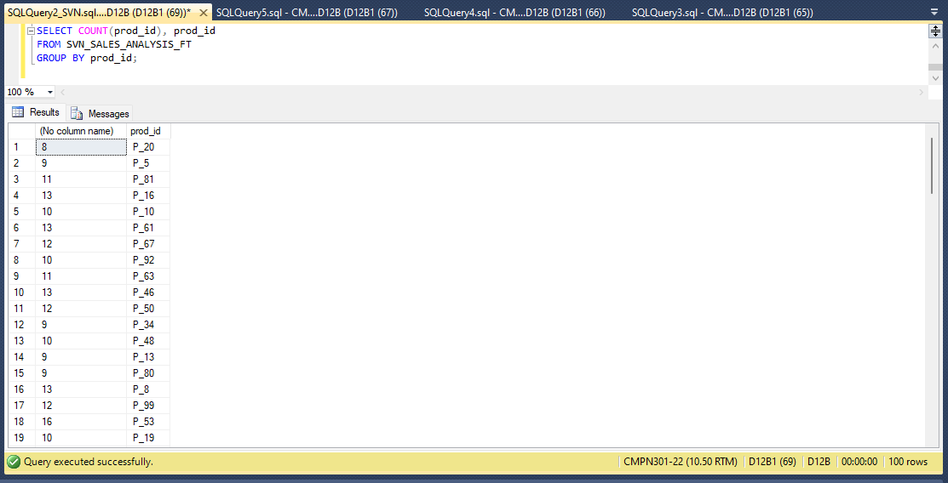

SELECT COUNT(prod_category), prod_category

FROM SVN_prod_dt

GROUP BY prod_category;

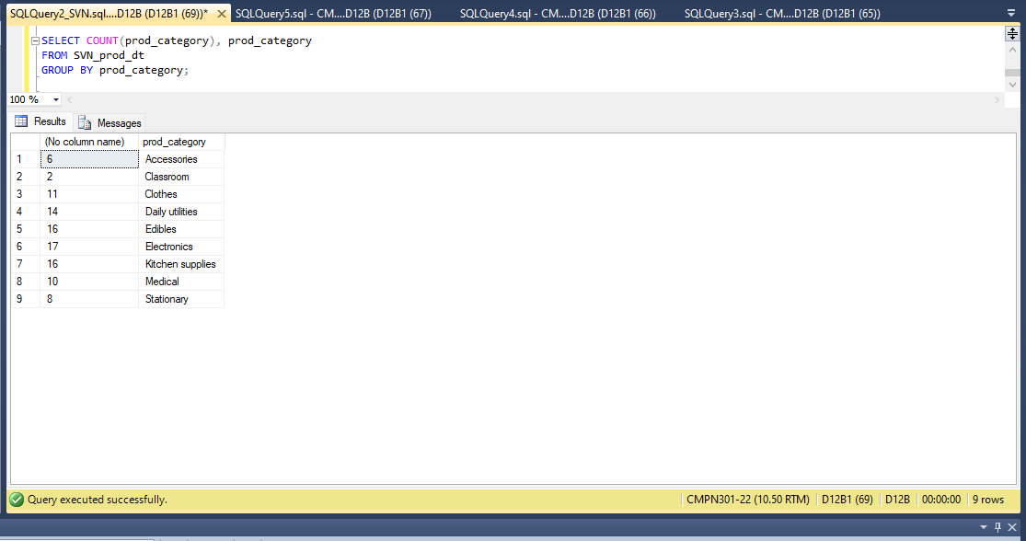

Select T.time_year, COUNT(FT.unit_sales) AS unit_sales

FROM SVN_SALES_ANALYSIS_FT AS FT , SVN_time_dt AS T

WHERE FT.time_id = T.time_id

GROUP BY T.time_year ORDER BY T.time_year;

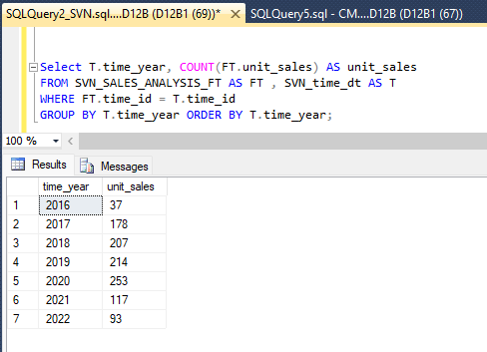

(ROLLUP - YEAR WISE UNIT SALES )

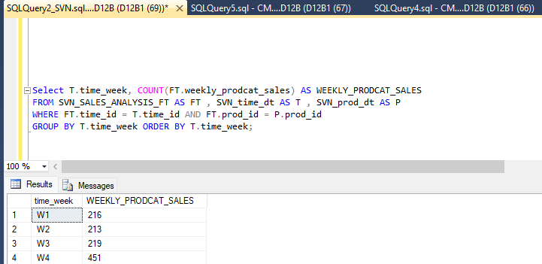

Select T.time_week, COUNT(FT.weekly_prodcat_sales) AS WEEKLY_PRODCAT_SALES

FROM SVN_SALES_ANALYSIS_FT AS FT , SVN_time_dt AS T , SVN_prod_dt AS P

WHERE FT.time_id = T.time_id AND FT.prod_id = P.prod_id

GROUP BY T.time_week ORDER BY T.time_week;

…………………………………………

1 way : prodwise daily sales

2 way : prodwise quarterly sales

3 way : prodcatwise monthly sales

……………………………………..

Rollup : yearly

Select T.time_year, COUNT(FT.unit_sales) AS yearly_sales

FROM SVN_SALES_ANALYSIS_FT AS FT , SVN_time_dt AS T , SVN_prod_dt AS P

WHERE FT.time_id = T.time_id AND FT.prod_id = P.prod_id

GROUP BY T.time_year ORDER BY T.time_year;

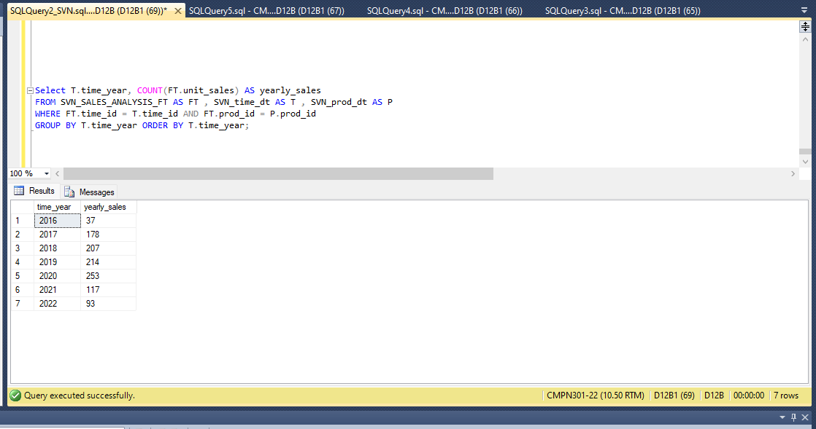

Drilldown : daily

Select T.time_date, COUNT(FT.unit_sales) AS daily_sales

FROM SVN_SALES_ANALYSIS_FT AS FT , SVN_time_dt AS T , SVN_prod_dt AS P

WHERE FT.time_id = T.time_id AND FT.prod_id = P.prod_id

GROUP BY T.time_date ORDER BY T.time_date;

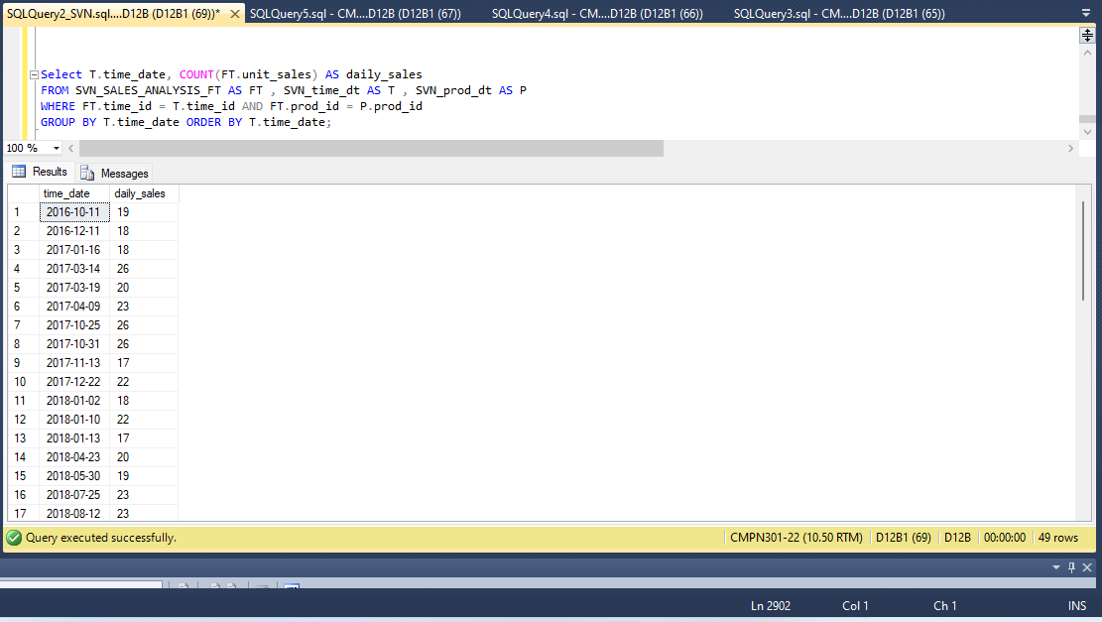

Weekly :

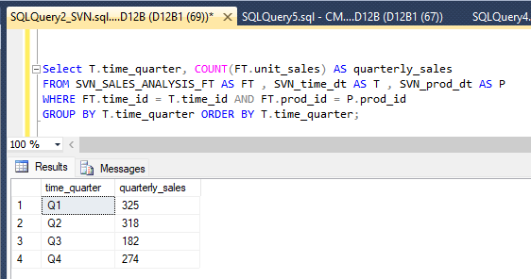

Monthly :

Select T.time_month, COUNT(FT.unit_sales) AS monthly_sales

FROM SVN_SALES_ANALYSIS_FT AS FT , SVN_time_dt AS T , SVN_prod_dt AS P

WHERE FT.time_id = T.time_id AND FT.prod_id = P.prod_id

GROUP BY T.time_month ORDER BY T.time_month;

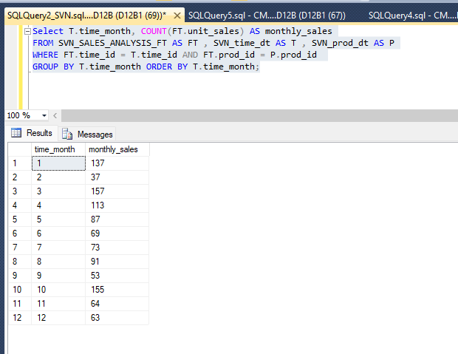

Slice :

Dice :

Pivot :

………………………….DRILL DOWN :

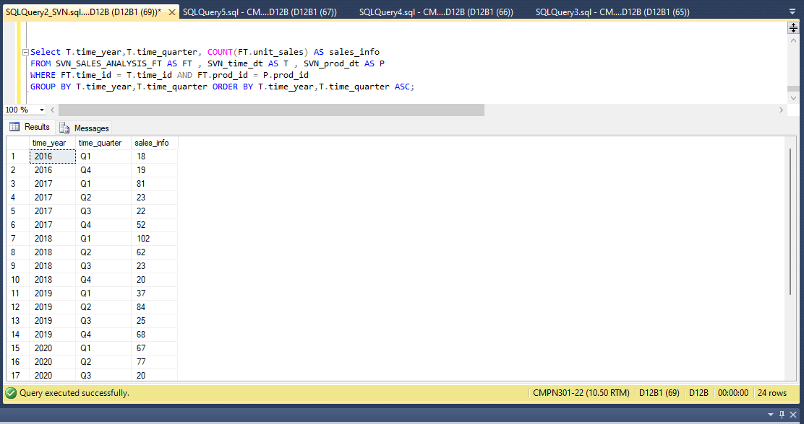

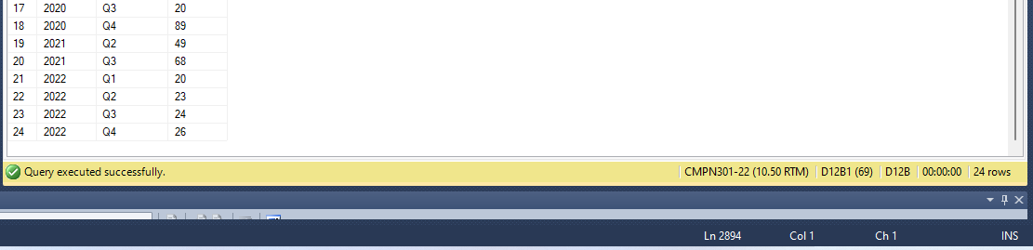

Select T.time_year,T.time_quarter, COUNT(FT.unit_sales) AS sales_info

FROM SVN_SALES_ANALYSIS_FT AS FT , SVN_time_dt AS T , SVN_prod_dt AS P

WHERE FT.time_id = T.time_id AND FT.prod_id = P.prod_id

GROUP BY T.time_year,T.time_quarter ORDER BY T.time_year,T.time_quarter ASC;